Deccan Education Society’s

Fergusson College (Autonomous), Pune - 4

**Department of Computer Science**

# A

# Project Report

# On

# *“ CertiPortal - Academic Certificate Generator* ”

# In partial fulfillment of Post Graduate course

# in

# M.Sc. Computer Science – I

# (Semester -II)

# CSC-560 Project

Under the Guidance of

Prof. Uma Madje

.

SUBMITTED BY

*Dhavale Ajinkya Balasaheb*



Deccan Education Society’s

Fergusson College (Autonomous), Pune

**Department of Computer Science**

# CERTIFICATE

This is to certify that the project entitled **CertiPortal - Academic Certificate Generator** submitted by Dhavale Ajinkya Balasaheb.

in partial fulfillment of the requirement of the completion of M.Sc. (C.S)-I [Semester-II], has been carried out by them under our guidance satisfactorily during the academic year 2024-2025.

Place: Pune

Date: / /2025

**Dr. Kavita Khobragade**

**Head,**

**Department of Computer Science**

**Fergusson College (Autonomous), Pune**

**Project Guide:**

1. Prof. Uma Madje

**Examiners Name Sign**

**1. ___________________________** ____________________

**2. ___________________________** ____________________

**Index**

|  |  |  |
| --- | --- | --- |
| **Sr. No** | **Table of Content** | **Page No** |
| **1** | **Introduction** | 4 |
| 1. Existing System | 4 |
| 1. Need of the System | 5 |
| 1. Overview of the Project | 6 |
| **2** | **Analysis** | 8 |
| 2.1 Feasibility Study | 8 |
| 2.1.1 Technical Feasibility | 8 |
| 2.1.2 Economical Feasibility | 8 |
| 2.1.3 Operational Feasibility | 9 |
| 2.2 Hardware and Software requirement | 9 |
| **3** | **Design** | 11 |
| 3.1 Database Table designing | 11 |
| 3.2 Software Engineering Diagrams | 17 |
| 3.3 Input & Output Screens | 23 |
| **4** | **Testing** | 34 |
| 4.1 Importance of testing | 34 |
| 4.2 Types of Testing | 35 |
| 4.3 Test Cases | 36 |
| **5** | **Reports** | 40 |
| **6** | **Drawbacks and Limitations** | 46 |
|  | 6.1 Drawbacks | 46 |
|  | 6.2 Limitations | 46 |
| **7** | **Future Enhancement and Conclusion** | 47 |
|  | 7.1 Future Enhancement | 47 |
|  | 7.2 Conclusion | 48 |
| **8** | **Bibliography** | 48 |

**1.Introduction**

This project focuses on creating a platform to automate the process of requesting, generating, and managing certificates. By streamlining these tasks, the platform helps reduce manual effort and ensures a more efficient, transparent system for students, administrators, and departmental staff. Students can easily request certificates, track notifications, and collect them, while administrators and departments like Library, Accounts, and Scholarship handle verification and approvals. Additionally, the platform supports real-time updates, ensuring that all parties have access to the most accurate information. It also helps in maintaining a secure and centralized database for certificates, reducing the risk of data loss or inaccuracies. The system enhances decision-making and provides a seamless user experience, offering easy access to important information and generating insightful reports for a better educational experience.

* 1. **Existing System**

In the existing system, if a student requires a Transfer Certificate or any other academic certificate, the process involves manually filling out an offline form. This method suffers from several drawbacks:

* **Inefficient Data Collection**

Offline forms do not capture or process data in a structured manner, leading to inconsistencies and incomplete records.

* **Lack of Centralized Database**

Information is scattered and not stored in a central location, increasing the risk of data loss or misplacement of documents.

* **Loss of Documents**

Physical documents are prone to loss, damage, or misfiling, which complicates retrieval and verification.

* **No Real-Time Notifications**

Students do not receive timely updates regarding the status of their requests, causing uncertainty and delays in the certificate issuance process.

* **Repetitive Office Visits**

Students often need to visit the office repeatedly to check on the status of their requests or to resubmit forms, which is time-consuming and inefficient.

* **Limited Transparency**

The manual process lacks transparency, making it difficult for students to track the progress of their requests or understand the reasons for any delays or rejections.

* **Error-Prone Manual Entry**

The reliance on manual data entry increases the likelihood of errors, which can lead to further delays and complications in processing certificate requests.

* **Ineffective Communication Between Departments**

Lack of integration among departments (e.g., Library, Accounts, Scholarship) results in fragmented verification processes and delays in certificate generation.

* **Environmental Impact**

The reliance on paper-based processes is not environmentally friendly and contributes to unnecessary paper waste.

* **Inefficient Record-Keeping and Retrieval**

Searching for archived records or verifying past requests is cumbersome due to the absence of a digital search functionality.

* 1. **Need of the System**
* **Automation of Processes**

Eliminate manual form filling by introducing an online request system.

* **Centralized Data Management**

Maintain all certificate-related information in a single, secure database to reduce data loss and simplify record retrieval.

* **Real-Time Notifications**

Provide instant updates on the status of certificate requests to keep students informed without the need for repeated office visits.

* **Streamlined Verification**

Integrate various departments (Library, Accounts, Scholarship) into a unified system to expedite verification and approval processes.

* **Error Reduction**

Minimize the likelihood of errors associated with manual data entry by automating data capture and validation.

* **Enhanced Transparency**

Enable students and staff to track requests throughout the process, ensuring clarity on pending, approved, or rejected applications.

* **Improved User Experience**

Offer a user-friendly interface that allows students to easily submit requests, manage documents, and check notifications.

* **Efficient Record-Keeping**

Facilitate quick and efficient search and retrieval of archived certificate data for future reference.

* **Cost and Time Efficiency**

Reduce administrative overhead and processing time, ultimately saving resources for both the institution and students.

* **Sustainable Practices**

Reduce reliance on paper-based forms, supporting environmental sustainability by digitizing the certificate request process.

* 1. **Overview of the Project**

The project introduces an automated platform that streamlines the academic certificate process by replacing traditional paper-based methods. The system is divided into two main modules and incorporates three essential submodules for enhanced verification, catering to specific user roles:

* **Main Modules**
* **Student Module**
* **Login and Dashboard Access :** Secure login grants students access to a personalized dashboard displaying pending requests, approved certificates, and notifications.
* **Profile Management :** Students can update personal details (name, address, contact information, academic records) and upload necessary documents (e.g., ID proof).
* **Certificate Request Submission :** Requests can be made for various certificates such as Transfer Certificate, Bonafide Certificate, and Attendance Certificate.
* **Request Tracking:**
* **Pending:** Awaiting admin verification.
* **Approved:** Ready for digital download or physical collection.
* **Disapproved:** Rejected with clear reasons, allowing students to resolve issues resubmit.
* **Document Management:**
* Facilitates the upload, update, and management of documents.
* Approved certificates are available for digital download, and students receive email notifications regarding the collection date and location for physical copies.
* **Secure Payment Handling :** Ensures safe processing of certificate processing fees.
* **Admin Module**
  + **Secure Login:** Admins log in using secure credentials to ensure authorized access.
  + **Personalized Dashboard:**
    - Displays pending, approved, and disapproved requests.
    - Shows real-time notifications and reminders.
    - Provides an overview of system statistics, such as daily request counts and pending verifications.
* **Detailed Review Process :** Admins meticulously check certificate requests against student records.
* **Integration with Submodules:**
* **Library:** Confirms no pending fines or overdue items.
* **Account:** Verifies that all fees and dues are cleared.
* **Scholarship:** Validates scholarship details and related records.
* **Approval Process:**
* Upon successful verification, requests are approved.
* The system auto-generates the corresponding certificates.
* Notifications are sent to students regarding their approved status.
* **Disapproval Process:**
* Requests with missing or incorrect details are rejected.
* Specific reasons for disapproval are provided.
* Instructions for corrections and resubmission are clearly communicated.
* **Automated Certificate Generation :** The system automatically generates certificates for approved requests.
* **Certificate History Log:** Maintains a record of all generated certificates for audit and future reference.
* **Sub Modules**
* **Library Module :** Checks for any pending issues such as overdue books or fines, confirming that all library requirements are fulfilled.
* **Account Module :** Verifies that students have no outstanding fees or dues, ensuring financial compliance before certificate issuance.
* **Scholarship Module :** Confirms scholarship details, if applicable, to ensure eligibility and accurate record keeping.

1. **Analysis**
   1. **Feasibility Study** 
      1. **Technical Feasibility**

* **Technology Stack:** The project will be built using established technologies (HTML, CSS, JavaScript, Bootstrap, Spring Boot, and MySQL), ensuring ample support and community expertise.
* **System Architecture:** The modular design, including separate modules for Students, Admins, and Verification (Scholarship, Account, Library), allows for easier maintenance and future scalability.
* **Development Expertise:** The required technical skills for frontend development, backend integration, and database management are readily available within the development team.
  + 1. **Economical Feasibility**
* **Cost Savings:** Automating the certificate management process reduces the need for manual labour and physical resources, leading to long-term cost savings.
* **Initial Investment vs. ROI (Return on investment):** While there is an initial investment in software development, training, and deployment, the reduction in administrative overhead and increased efficiency promise a high return on investment

.

* **Resource Utilization:** The project leverages existing IT infrastructure and integrates with current university systems, minimizing additional expenses.
* **Scalability:** A scalable solution means that the system can grow with increased demand without significant additional cost.
  + 1. **Operational Feasibility**
* **User Acceptance:** The system provides an intuitive and user-friendly interface for both students and administrators, which is expected to lead to high user adoption.
* **Process Efficiency:** Automation of certificate requests, real-time notifications, and integrated verification processes will streamline operations and reduce processing time.
* **Training and Support:** Minimal training is required as the system is designed with simplicity in mind, and support resources can be developed as part of the implementation process.
* **Reliability and Maintenance:** The use of proven technologies ensures system reliability, while modularity simplifies ongoing maintenance and troubleshooting.
  1. **Hardware and Software Requirements**
* **Minimum Hardware Requirements**
* **Server:**
  + **Processor:** Dual-core CPU (or equivalent).
  + **Memory:** Minimum 4 GB RAM.
  + **Storage:** At least 20 GB of available disk space.
  + **Network:** Reliable internet connection for hosting and access.
* **Client Devices:**
* **Device:** Desktop, laptop, tablet or mobile.
* **Memory:** Basic modern computer sufficient to run a web browser.
* **Display:** Screen resolution that supports standard web interfaces.
* **Internet:** Stable connection to access the online platform.
* **Software Requirements**
* **Operating System (Server):** Linux (e.g., Ubuntu Server) or Windows Server.
* **Backend:**
* **Programming Environment:** Java Development Kit (JDK 17 or higher)
* **Framework:** Spring Boot.
* **Application Server:** Embedded server (e.g., Tomcat via Spring Boot)
* **Database:** MySQL.
* **Frontend:**
  + **Languages:** HTML, CSS, JavaScript.
  + **Framework:** Bootstrap, AJAX.
  + **Library:** jQuery.
* **Development Tools:**
* IDE(Integrated Development Environment): Visual Studio Code, Spring Tool Suit
* Version Control System : Git
* **Browser (Client Side):**
* Latest version of any modern web browser (e.g., Google Chrome, Mozilla Firefox)

1. **Design**
   1. **Database Table Designing**
2. **Admission Table**

|  |  |  |  |  |
| --- | --- | --- | --- | --- |
| **Sr. No** | **Name** | **Type** | **Length** | **Constraints** |
| 1 | id | bigint | 20 | PRIMARY KEY, AUTO_INCREMENT,  NOT NULL |
| 2 | aadhar_no | varchar | 255 | NOT NULL, INDEX |
| 3 | admission_generated_id | varchar | 255 | NOT NULL, INDEX |
| 4 | email | varchar | 255 | NOT NULL, INDEX |
| 5 | first_name | varchar | 255 | NOT NULL |
| 6 | flag | int | 11 | NOT NULL |
| 7 | last_name | varchar | 255 | NOT NULL |
| 8 | middle_name | varchar | 255 | NULL |
| 9 | password | varchar | 255 | NOT NULL |
| 10 | start_date | varchar | 255 | NOT NULL |

1. **Personal Details Table**

|  |  |  |  |  |
| --- | --- | --- | --- | --- |
| **Sr. No** | **Name** | **Type** | **Length** | **Constraints** |
| 1 | id | bigint | 20 | PRIMARY KEY, AUTO_INCREMENT,  NOT NULL |
| 2 | abc_number | varchar | 255 | NULL |
| 3 | blood_group | varchar | 255 | NOT NULL |
| 4 | caste | varchar | 255 | NOT NULL |
| 5 | dob | varchar | 255 | NOT NULL |
| 6 | family_income | varchar | 255 | NOT NULL |
| 7 | father_name | varchar | 255 | NOT NULL |
| 8 | father_occupation | varchar | 255 | NOT NULL |
| 9 | gender | varchar | 255 | NOT NULL |
| 10 | handicap | varchar | 255 | NULL |
| 11 | handicap_percentage | varchar | 255 | NULL |
| 12 | marital_status | varchar | 255 | NOT NULL |
| 13 | mobile | varchar | 255 | NOT NULL |
| 14 | mother_name | varchar | 255 | NOT NULL |
| 15 | mother_occupation | varchar | 255 | NOT NULL |
| 16 | mother_tongue | varchar | 255 | NOT NULL |
| 17 | nationality | varchar | 255 | NOT NULL |
| 18 | occupation | varchar | 255 | NOT NULL |
| 19 | pan_number | varchar | 255 | NULL |
| 20 | parent_mobile | varchar | 255 | NULL |
| 21 | place_of_birth | varchar | 255 | NOT NULL |
| 22 | religion | varchar | 255 | NOT NULL |
| 23 | student_id | varchar | 255 | NOT NULL |
| 24 | sub_caste | varchar | 255 | NOT NULL |

|  |  |  |  |  |
| --- | --- | --- | --- | --- |
| **Sr. No** | **Name** | **Type** | **Length** | **Constraints** |
| 1 | id | bigint | 20 | PRIMARY KEY, AUTO_INCREMENT,  NOT NULL |
| 2 | permanent_address | varchar | 255 | NOT NULL |
| 3 | permanent_city | varchar | 255 | NOT NULL |
| 4 | permanent_country | varchar | 255 | NOT NULL |
| 5 | permanent_district | varchar | 255 | NOT NULL |
| 6 | permanent_pincode | varchar | 255 | NOT NULL |
| 7 | permanent_state | varchar | 255 | NOT NULL |
| 8 | permanent_taluka | varchar | 255 | NOT NULL |
| 9 | same_as_permanent | bit | 1 | NOT NULL |
| 10 | student_id | varchar | 255 | NOT NULL |
| 11 | temporary_address | varchar | 255 | NOT NULL |
| 12 | temporary_city | varchar | 255 | NOT NULL |
| 13 | temporary_country | varchar | 255 | NOT NULL |
| 14 | temporary_district | varchar | 255 | NOT NULL |
| 15 | temporary_pincode | varchar | 255 | NOT NULL |
| 16 | temporary_state | varchar | 255 | NOT NULL |
| 17 | temporary_taluka | varchar | 255 | NOT NULL |

1. **Address Table**
2. **Academic Details Table**

|  |  |  |  |  |
| --- | --- | --- | --- | --- |
| **Sr. No** | **Name** | **Type** | **Length** | **Constraints** |
| 1 | id | bigint | 20 | PRIMARY KEY, AUTO_INCREMENT,  NOT NULL |
| 2 | admission_year | varchar | 255 | NOT NULL |
| 3 | course | varchar | 255 | NOT NULL |
| 4 | department | varchar | 255 | NOT NULL |
| 5 | full_name | varchar | 255 | NOT NULL |
| 6 | medium | varchar | 255 | NOT NULL |
| 7 | previous_college_name | varchar | 255 | NOT NULL |
| 8 | previous_course_name | varchar | 255 | NOT NULL |
| 9 | previous_passing_year | varchar | 255 | NOT NULL |
| 10 | previous_year_percentage | varchar | 255 | NOT NULL |
| 11 | section | varchar | 255 | NOT NULL |
| 12 | session | varchar | 255 | NOT NULL |
| 13 | student_id | varchar | 255 | NOT NULL |
|  |  |  |  |  |

1. **Student Documents Table**

|  |  |  |  |  |
| --- | --- | --- | --- | --- |
| **Sr. No** | **Name** | **Type** | **Length** | **Constraints** |
| 1 | id | bigint | 20 | PRIMARY KEY, AUTO_INCREMENT,  NOT NULL |
| 2 | photo | varchar | 255 | NULL |
| 3 | sign | varchar | 255 | NULL |
| 4 | student_id | varchar | 255 | NOT NULL |

1. **Transfereence Certificate Table**

|  |  |  |  |  |
| --- | --- | --- | --- | --- |
| **Sr. No** | **Name** | **Type** | **Length** | **Constraints** |
| 1 | id | bigint | 20 | PRIMARY KEY, AUTO_INCREMENT,  NOT NULL |
| 2 | account_approval | int | 11 | NOT NULL |
| 3 | address | varchar | 255 | NOT NULL |
| 4 | admin_approval | int | 11 | NOT NULL |
| 5 | new_admission_type | varchar | 255 | NOT NULL |
| 6 | alternate_no | varchar | 255 | NOT NULL |
| 7 | application_date | datetime | 6 | NOT NULL |
| 8 | application_fee | double | - | NOT NULL |
| 9 | birth_date_proof | varchar | 255 | NOT NULL |
| 10 | caste_category | varchar | 255 | NOT NULL |
| 11 | certificate_reason | varchar | 255 | NOT NULL |
| 12 | certificate_type | varchar | 255 | NOT NULL |
| 13 | college_name | varchar | 255 | NOT NULL |
| 14 | contact_no | varchar | 255 | NOT NULL |
| 15 | course | varchar | 255 | NOT NULL |
| 16 | department | varchar | 255 | NOT NULL |
| 17 | dob | varchar | 255 | NOT NULL |
| 18 | dob_in_words | varchar | 255 | NOT NULL |
| 19 | email_id | varchar | 255 | NOT NULL |
| 20 | first_name | varchar | 255 | NOT NULL |
| 21 | gender | varchar | 255 | NOT NULL |
| 22 | identity_proof | varchar | 255 | NOT NULL |
| 23 | last_cgpa | varchar | 255 | NOT NULL |
| 24 | last_class | varchar | 255 | NOT NULL |
| 25 | last_exam_month | varchar | 255 | NOT NULL |
| 26 | last_exam_name | varchar | 255 | NOT NULL |
| 27 | last_exam_year | varchar | 255 | NOT NULL |
| 28 | last_grade | varchar | 255 | NOT NULL |
| 29 | last_name | varchar | 255 | NOT NULL |
| 30 | last_result | varchar | 255 | NOT NULL |
| 31 | last_seat_no | varchar | 255 | NOT NULL |
| 32 | last_sem | varchar | 255 | NOT NULL |
| 33 | latest_marksheet | varchar | 255 | NOT NULL |
| 34 | library_approval | int | 11 | NOT NULL |
| 35 | middle_name | varchar | 255 | NOT NULL |
| 36 | new_course | varchar | 255 | NOT NULL |
| 37 | passing_certificate | varchar | 255 | NOT NULL |
| 38 | payment_date | datetime | 6 | NOT NULL |
| 39 | payment_id | varchar | 255 | NOT NULL |
| 40 | payment_status | varchar | 255 | NOT NULL |
| 41 | processing_fee | double | - | NOT NULL |
| 42 | proof_of_admission | varchar | 255 | NOT NULL |
| 43 | scholarship_approval | int | 11 | NOT NULL |
| 44 | student_id | varchar | 255 | NOT NULL |
| 45 | tc_type | varchar | 255 | NOT NULL |
| 46 | total_fee | double | - | NOT NULL |
| 47 | university_name | varchar | 255 | NOT NULL |
| 48 | issue_date | datetime | 6 | NOT NULL |

1. **Bonafide Certificate Table**

|  |  |  |  |  |
| --- | --- | --- | --- | --- |
| **Sr. No** | **Name** | **Type** | **Length** | **Constraints** |
| 1 | id | bigint | 20 | PRIMARY KEY, AUTO_INCREMENT,  NOT NULL |
| 2 | admin_approval | int | 11 | NOT NULL |
| 3 | application_date | datetime | 6 | NOT NULL |
| 4 | birth_proof_path | varchar | 255 | NOT NULL |
| 5 | certificate_reason | varchar | 255 | NOT NULL |
| 6 | certificate_type | varchar | 255 | NOT NULL |
| 7 | course | varchar | 255 | NOT NULL |
| 8 | department | varchar | 255 | NOT NULL |
| 9 | division | varchar | 255 | NOT NULL |
| 10 | dob | varchar | 255 | NOT NULL |
| 11 | dob_in_words | varchar | 255 | NOT NULL |
| 12 | fee_receipt_path | varchar | 255 | NOT NULL |
| 13 | full_name | varchar | 255 | NOT NULL |
| 14 | gender | varchar | 255 | NOT NULL |
| 15 | identity_proof_path | varchar | 255 | NOT NULL |
| 16 | local_address | varchar | 255 | NOT NULL |
| 17 | payment_id | varchar | 255 | NOT NULL |
| 18 | payment_status | varchar | 255 | NOT NULL |
| 19 | permanent_address | varchar | 255 | NOT NULL |
| 20 | student_id | varchar | 255 | NOT NULL |
| 21 | total_fees | double | - | NOT NULL |
| 22 | year | varchar | 255 | NOT NULL |
| 23 | issue_date | datetime | 6 | NOT NULL |

1. **Attendence Certificate Table**

|  |  |  |  |  |
| --- | --- | --- | --- | --- |
| **Sr. No** | **Name** | **Type** | **Length** | **Constraints** |
| 1 | id | bigint | 20 | PRIMARY KEY, AUTO_INCREMENT,  NOT NULL |
| 2 | admin_approval | int | 11 | NOT NULL |
| 3 | application_date | datetime | 6 | NOT NULL |
| 4 | certificate_reason | varchar | 255 | NOT NULL |
| 5 | certificate_type | varchar | 255 | NOT NULL |
| 6 | course | varchar | 255 | NOT NULL |
| 7 | department | varchar | 255 | NOT NULL |
| 8 | division | varchar | 255 | NOT NULL |
| 9 | fee_receipt_path | varchar | 255 | NOT NULL |
| 10 | from_date | varchar | 255 | NOT NULL |
| 11 | full_name | varchar | 255 | NOT NULL |
| 12 | gender | varchar | 255 | NOT NULL |
| 13 | identity_proof_path | varchar | 255 | NOT NULL |
| 14 | issue_date | datetime | 6 | NOT NULL |
| 15 | student_id | varchar | 255 | NOT NULL |
| 16 | teacher_name | varchar | 255 | NOT NULL |
| 17 | teacher_verified_date | varchar | 255 | NOT NULL |
| 18 | to_date | varchar | 255 | NOT NULL |
| 19 | verification_letter_path | varchar | 255 | NOT NULL |
| 20 | year | varchar | 255 | NOT NULL |

1. **Admin Table**

|  |  |  |  |  |
| --- | --- | --- | --- | --- |
| **Sr. No** | **Name** | **Type** | **Length** | **Constraints** |
| 1 | admin_id | bigint | 20 | PRIMARY KEY, AUTO_INCREMENT,  NOT NULL |
| 2 | password | varchar | 255 | NOT NULL |
| 3 | role | varchar | 255 | NOT NULL |
| 4 | username | varchar | 255 | NOT NULL, INDEX |

* 1. **Software Engineering Diagram**

1. **Entity Relationship Diagram**

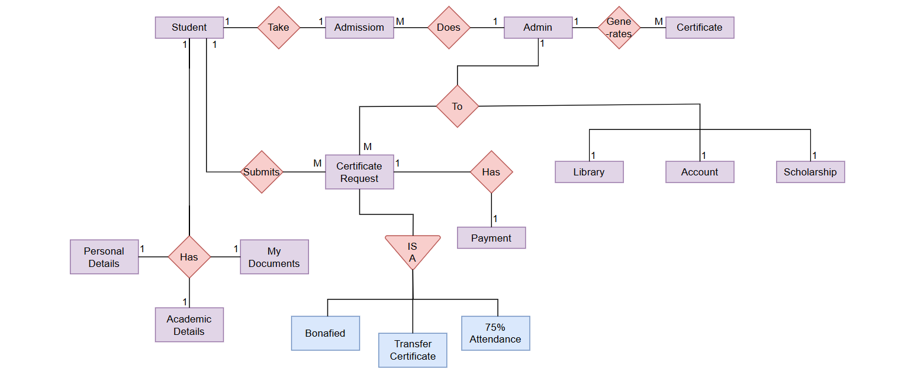

1. **Activity Diagram**

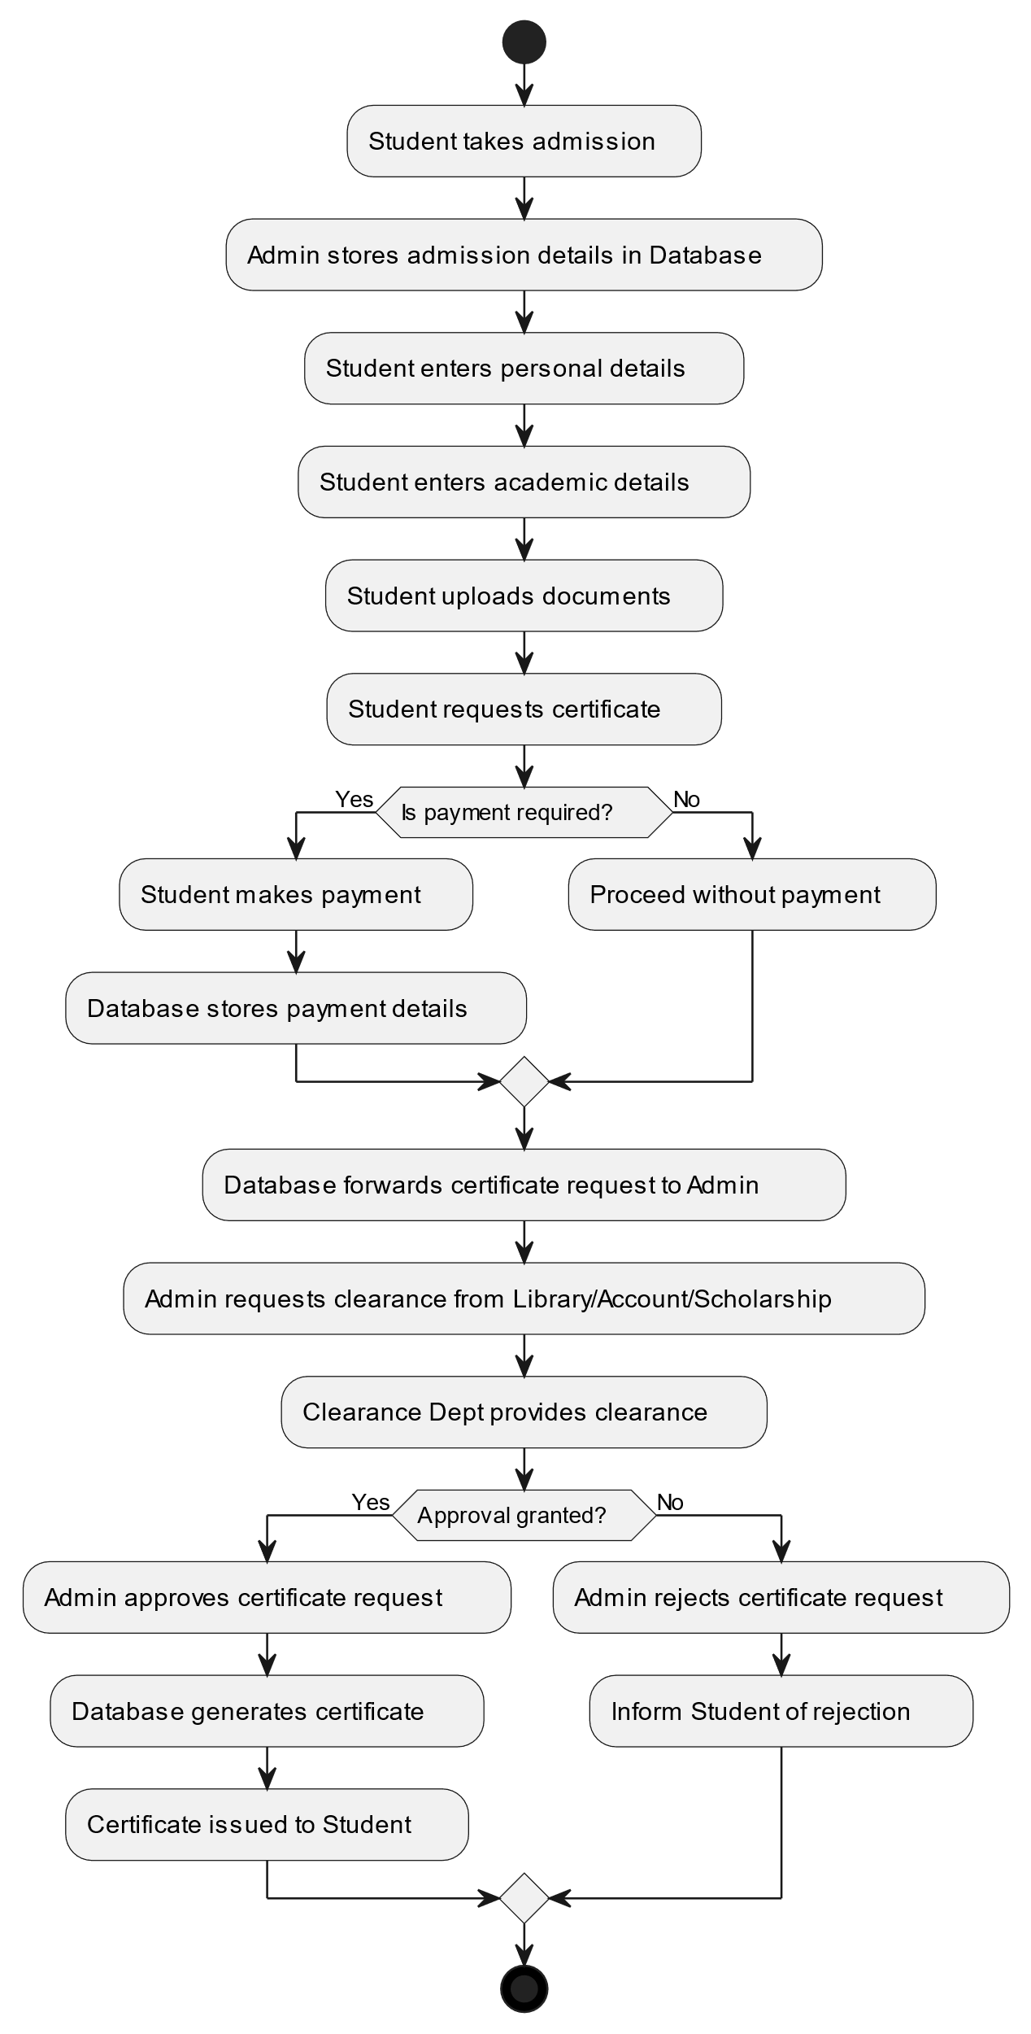

1. **Sequence Diagram**

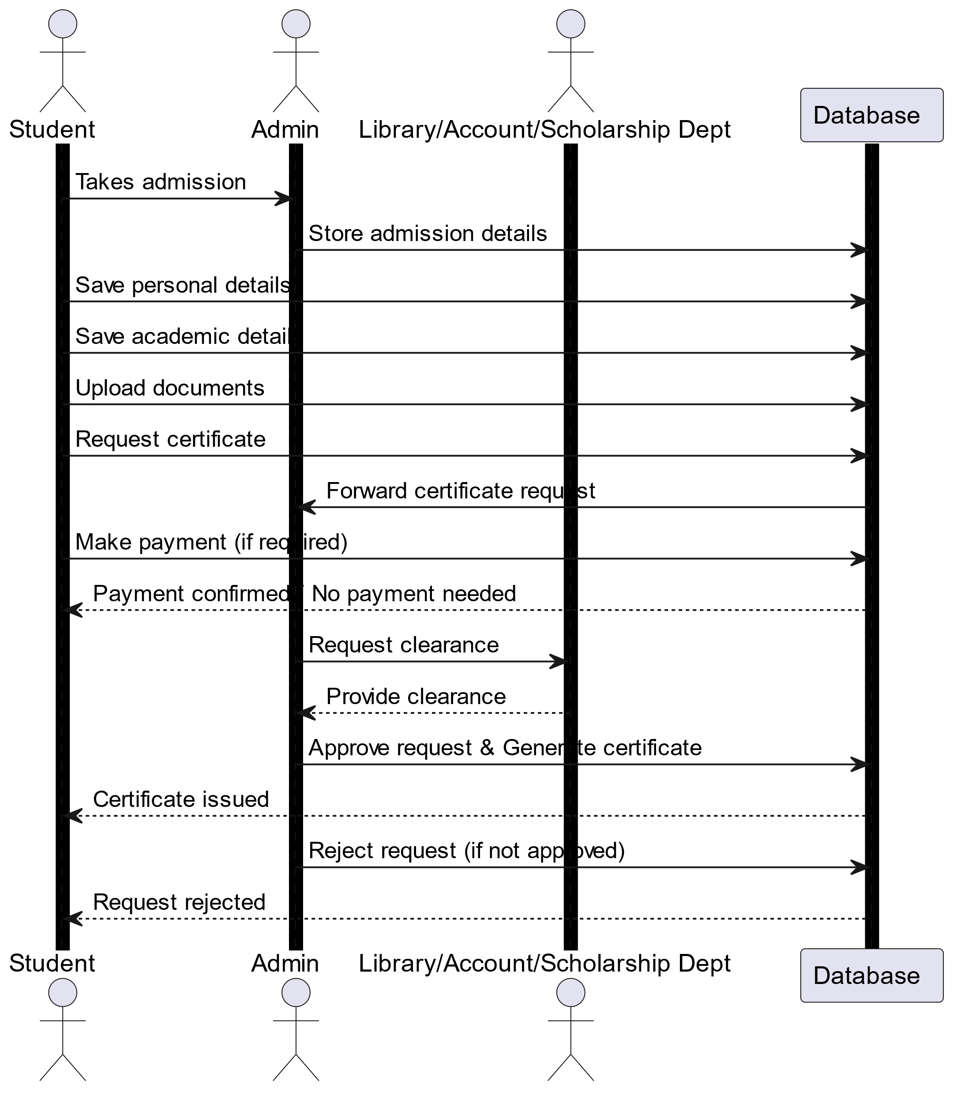

1. **Use Case Diagram**

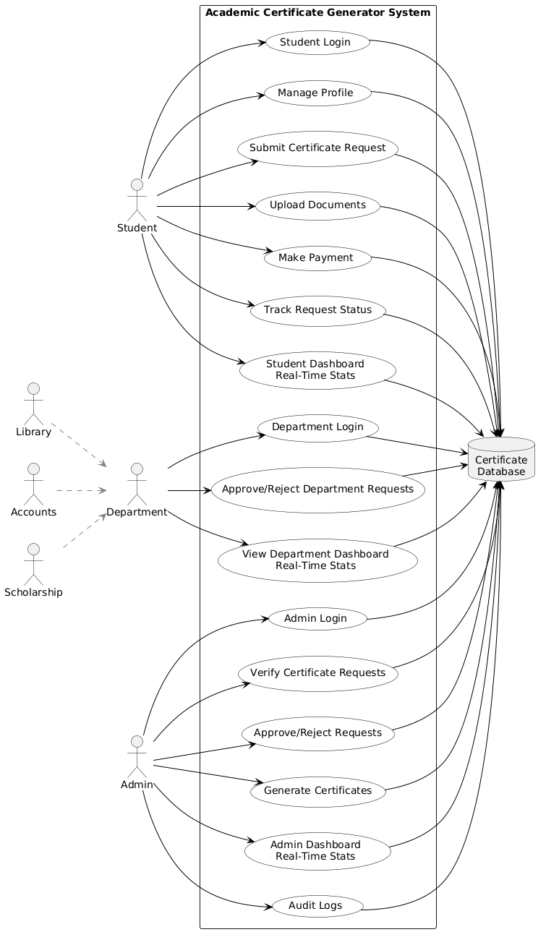

1. **Component Diagram**

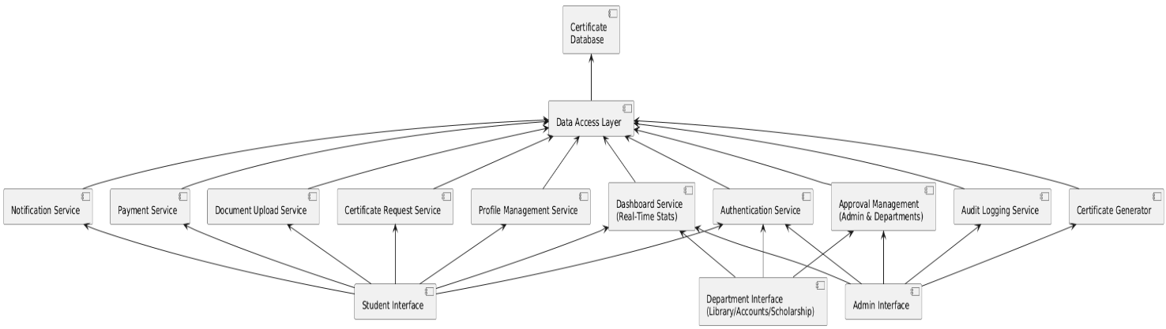

1. **Deployment Diagram**

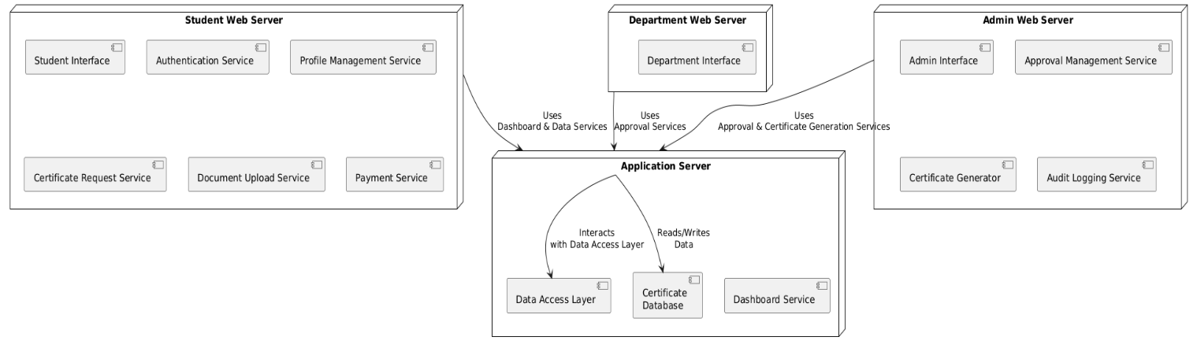

1. **DFD**

**Level 0 DFD**

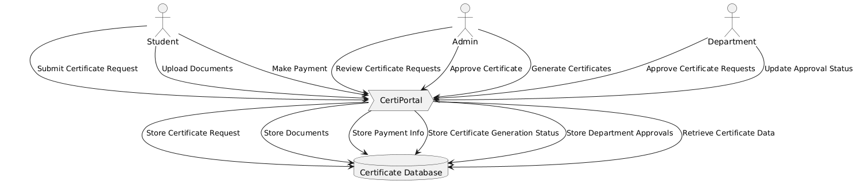

**Level 1 DFD**

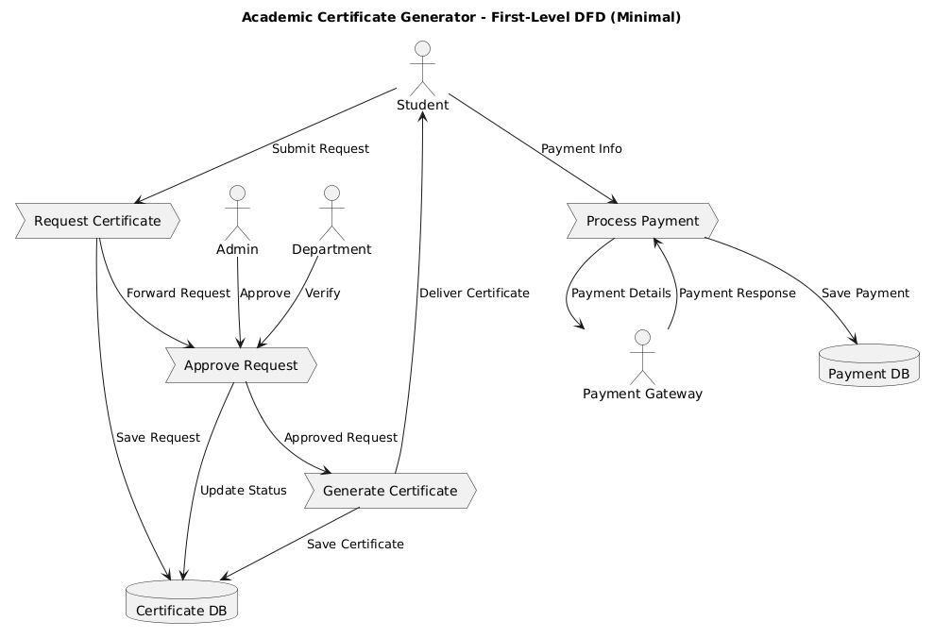

* 1. **Input and Output Screens**

**1. Student And Admin Login Screens**

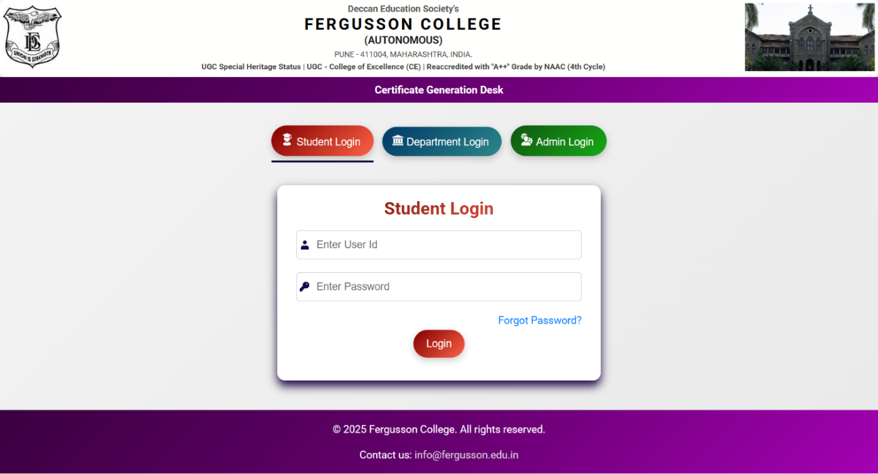

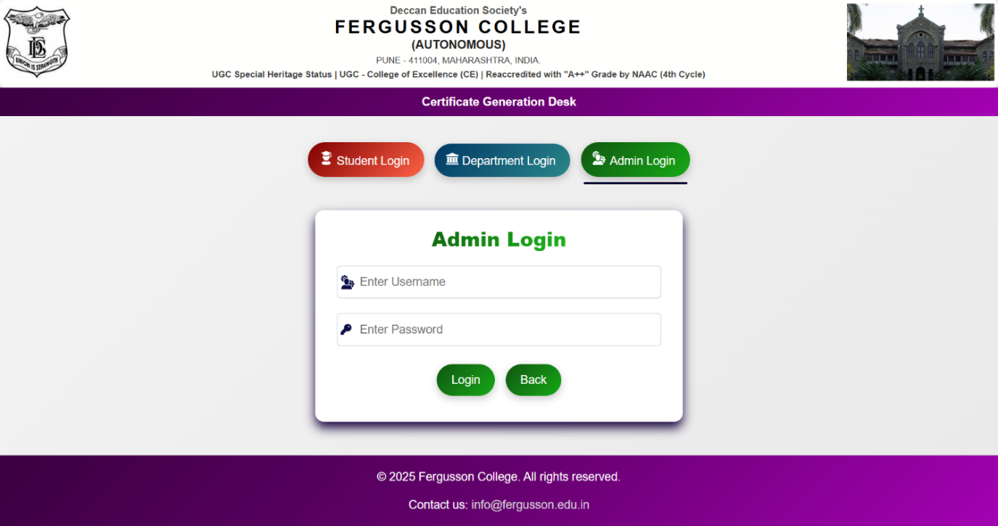

1. Student Module Screen

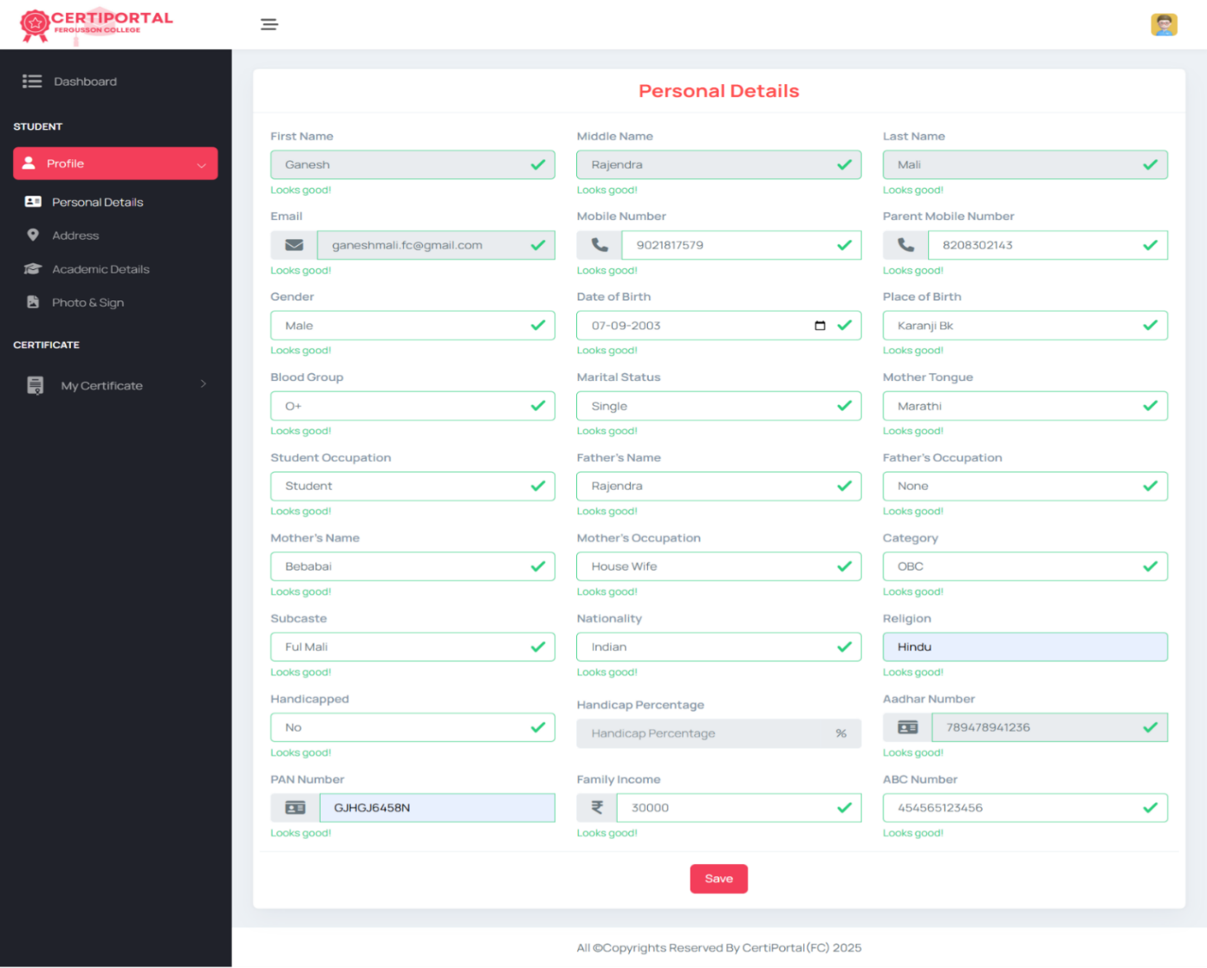

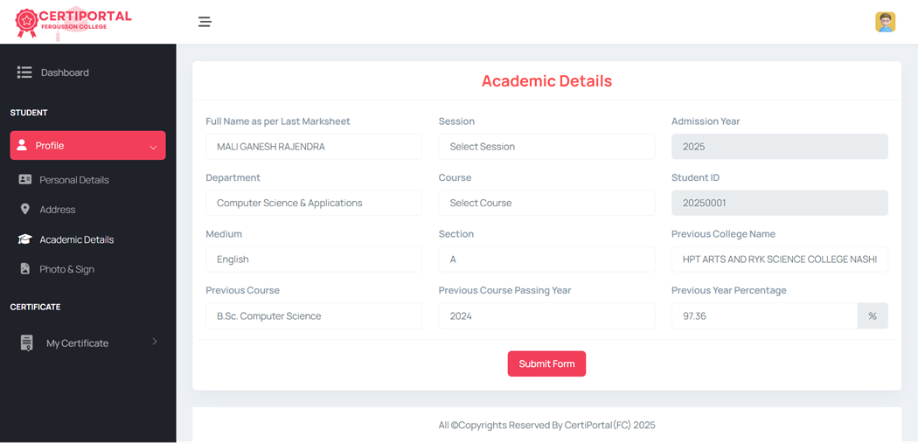

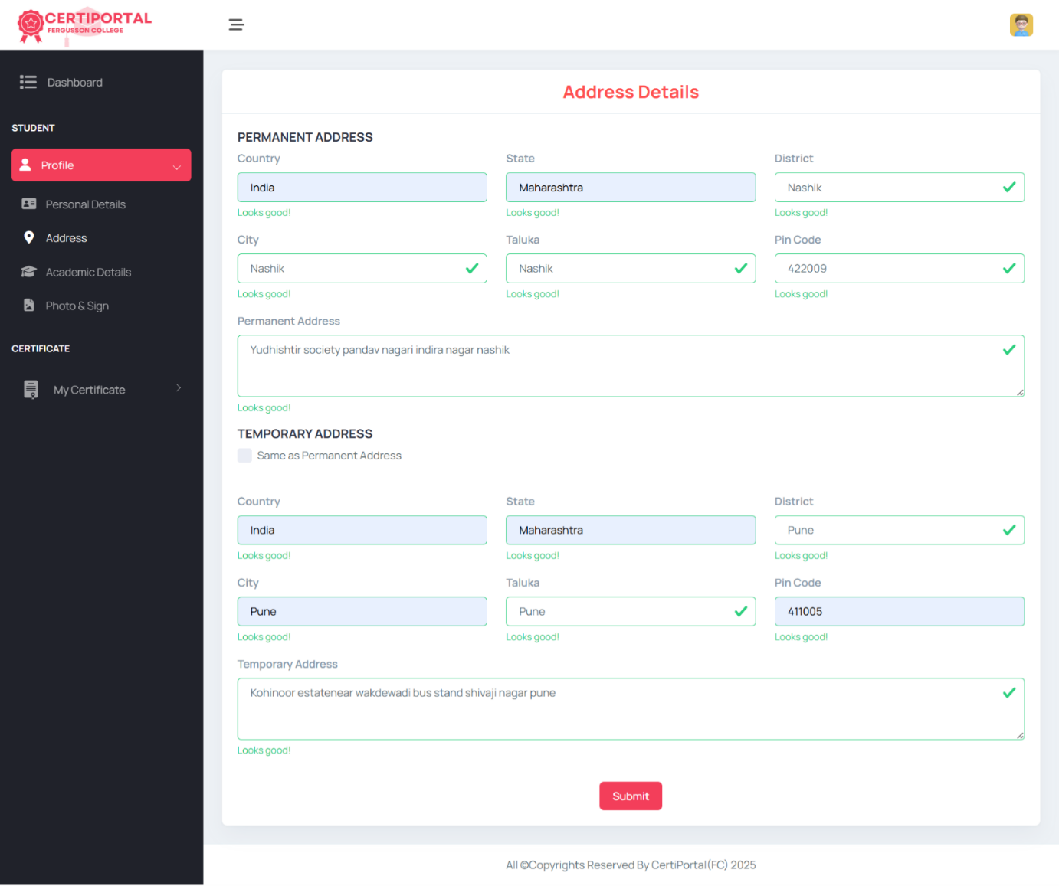

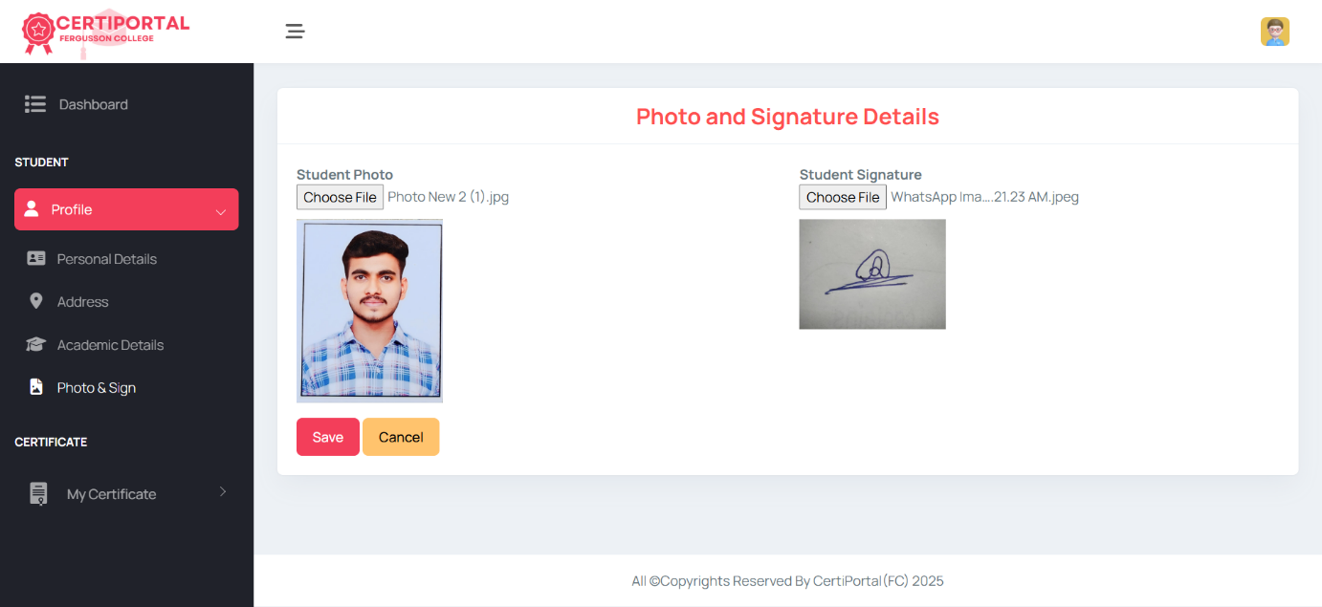

Certificate Applications:

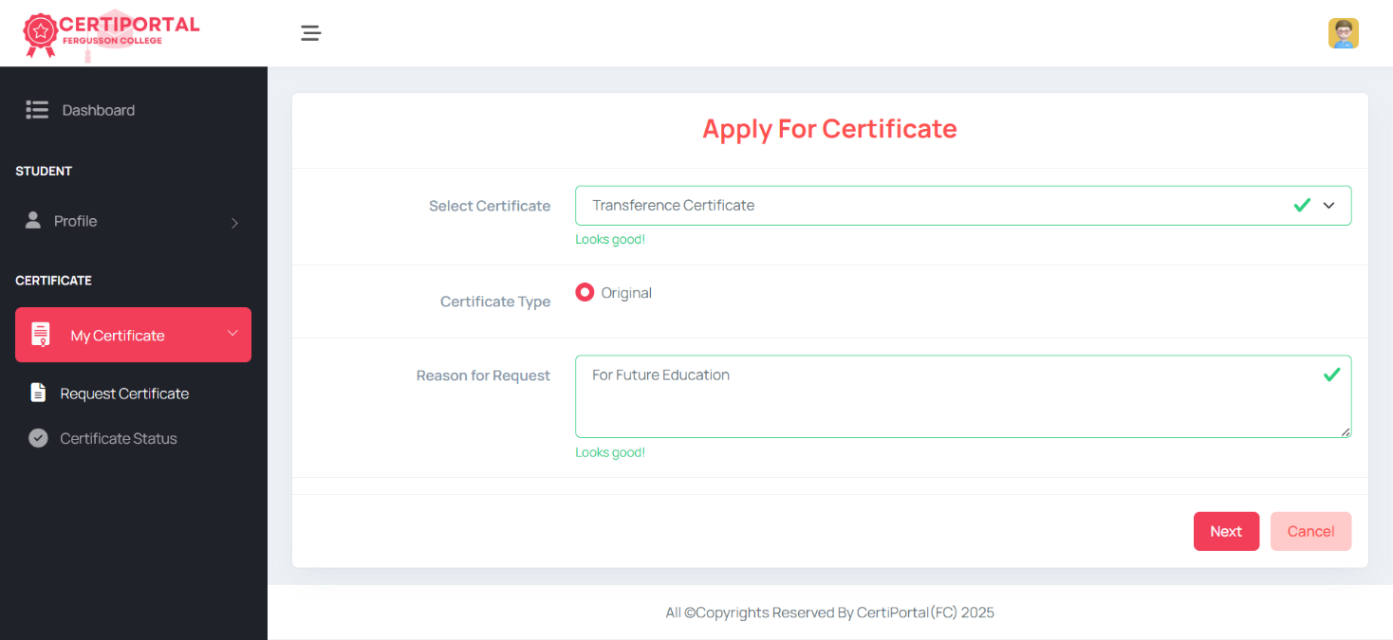

1) Transference Certificate

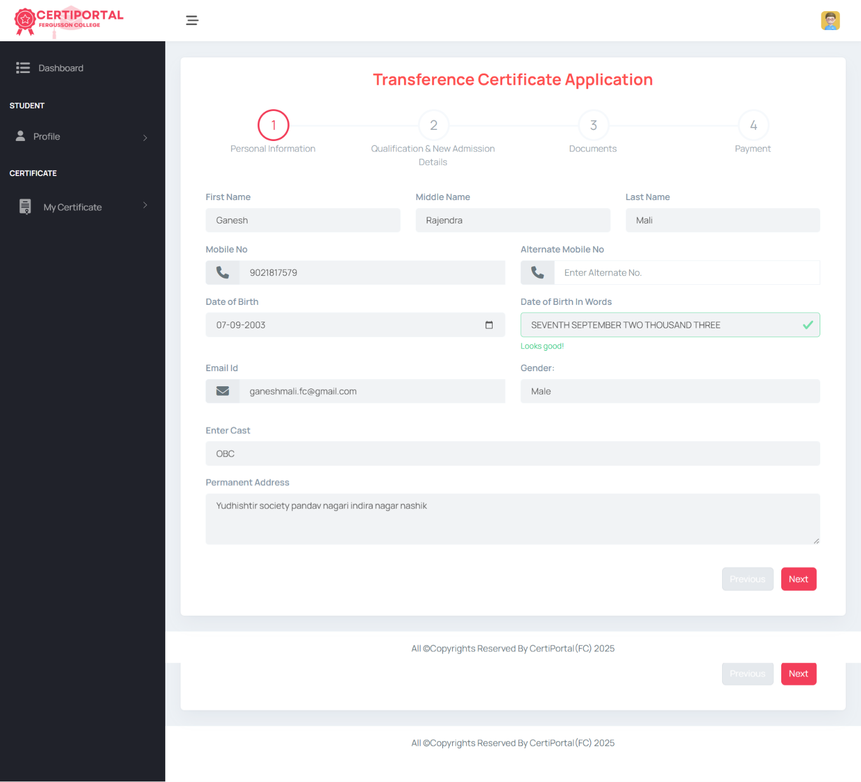

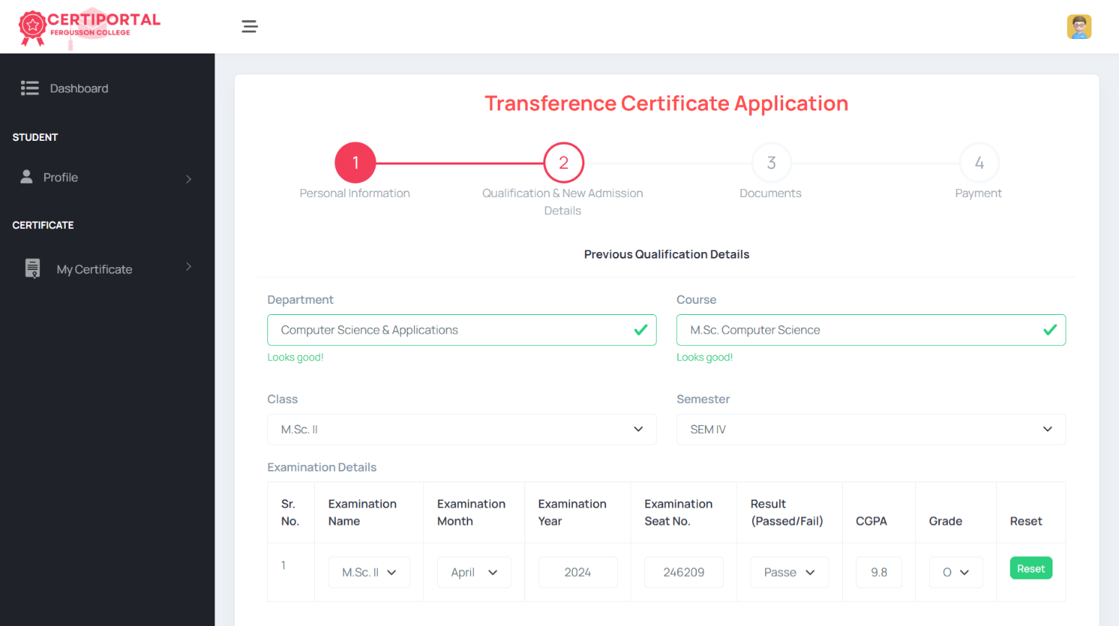

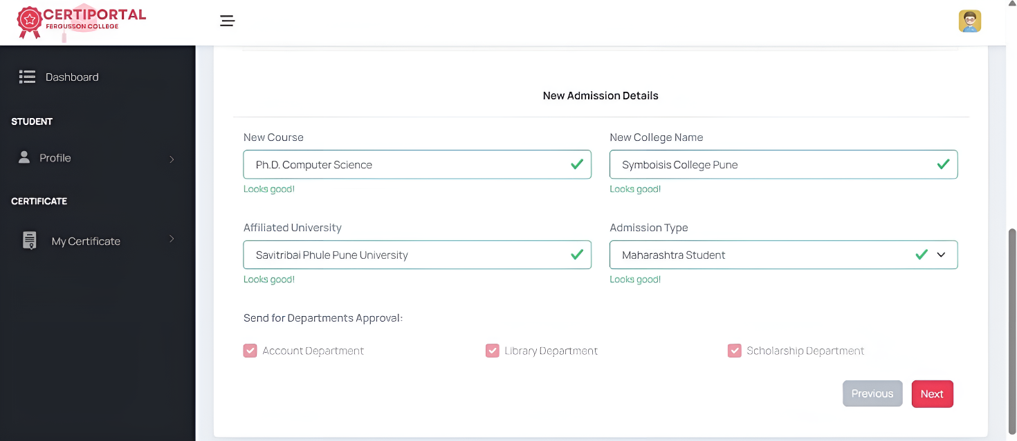

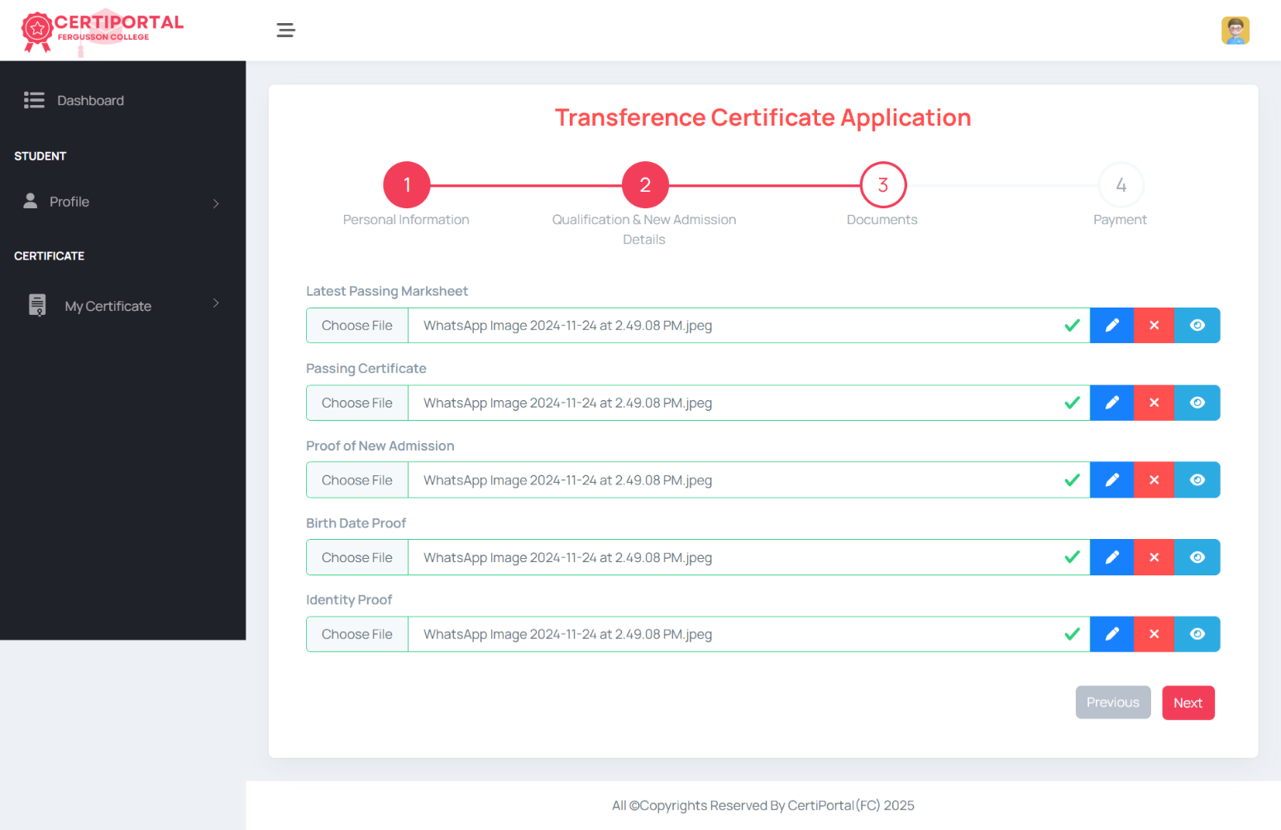

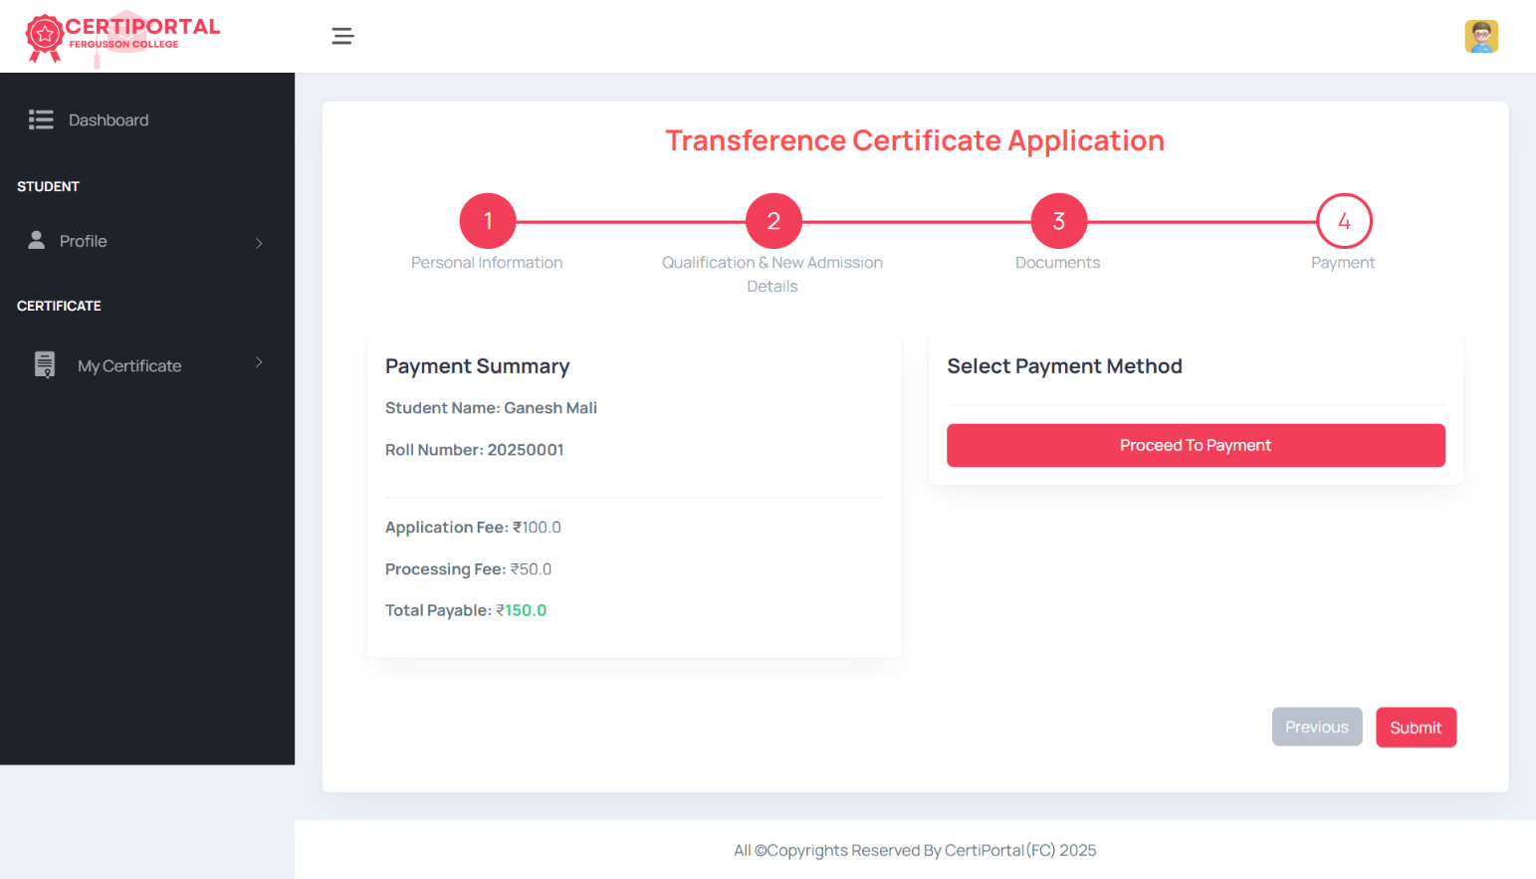

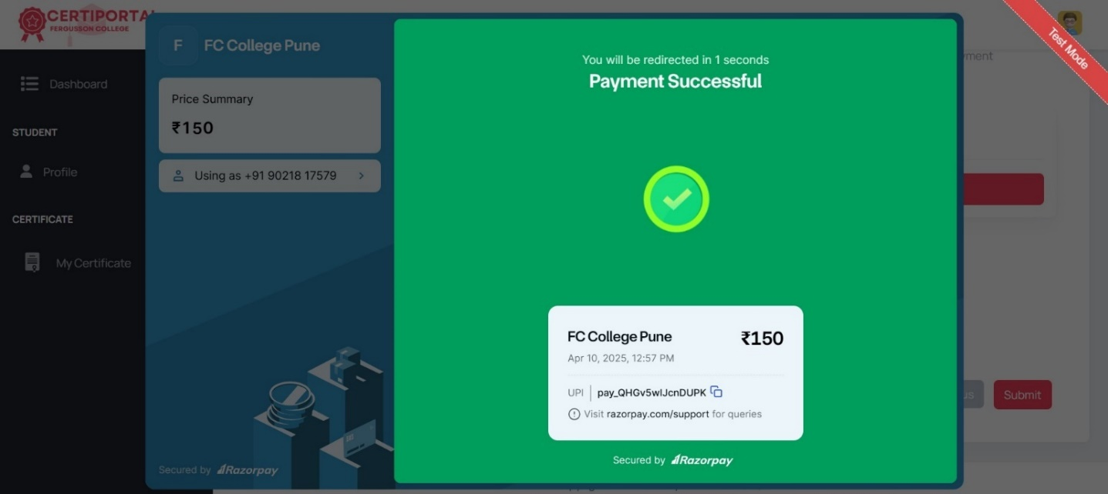

2) Bonafide Certificate

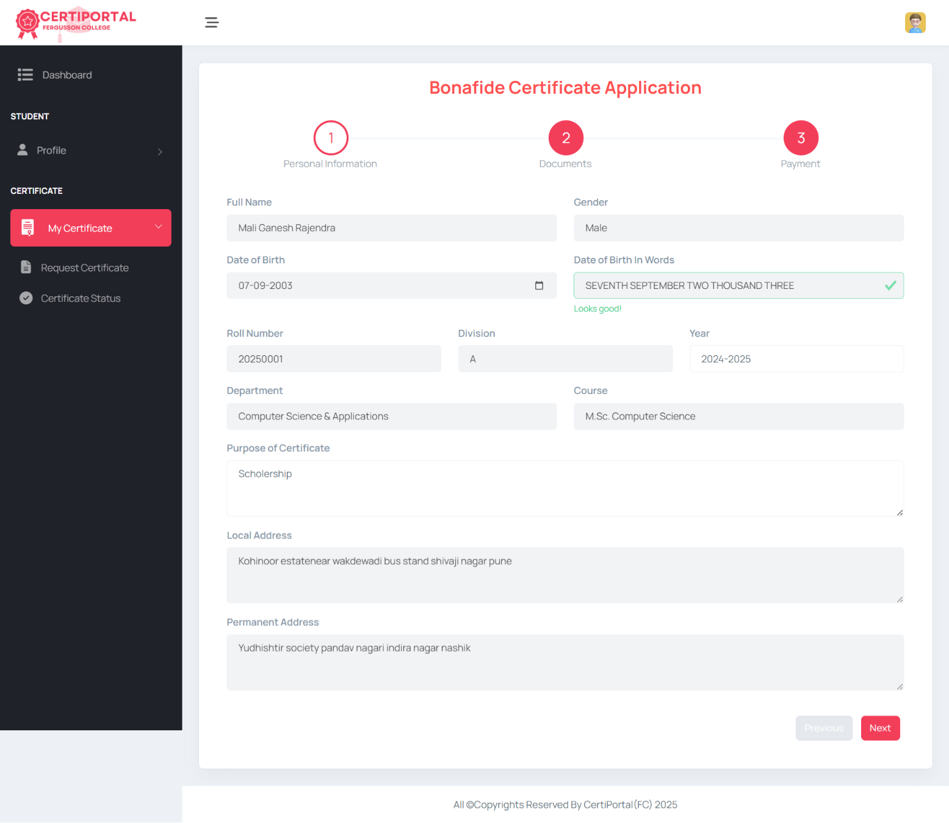

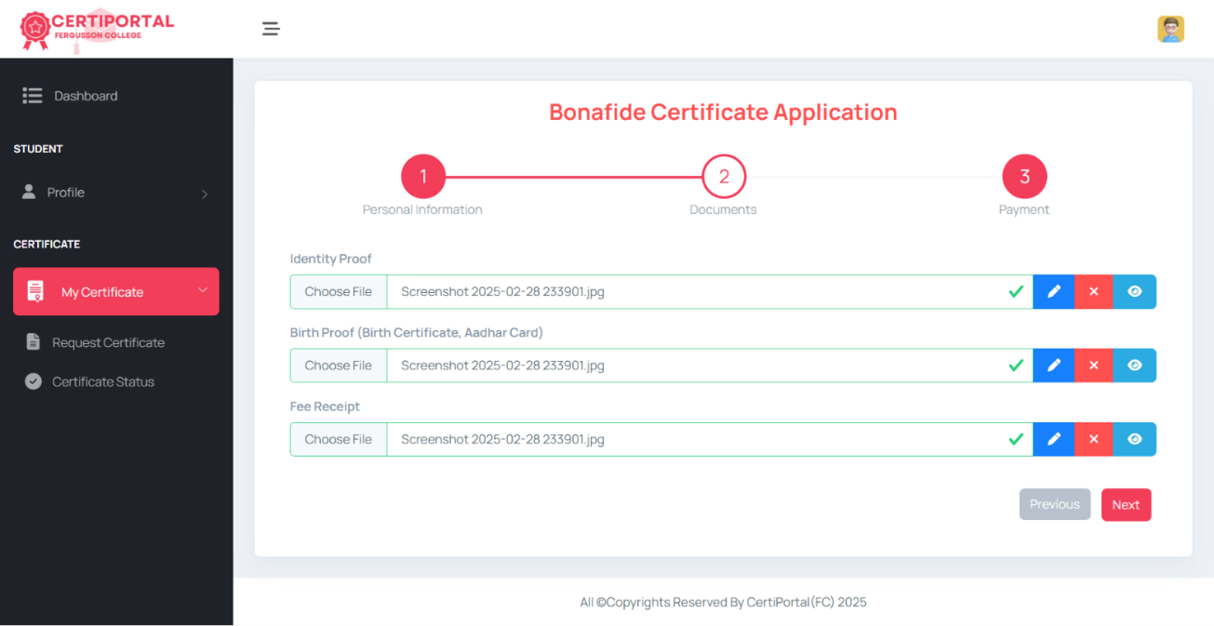

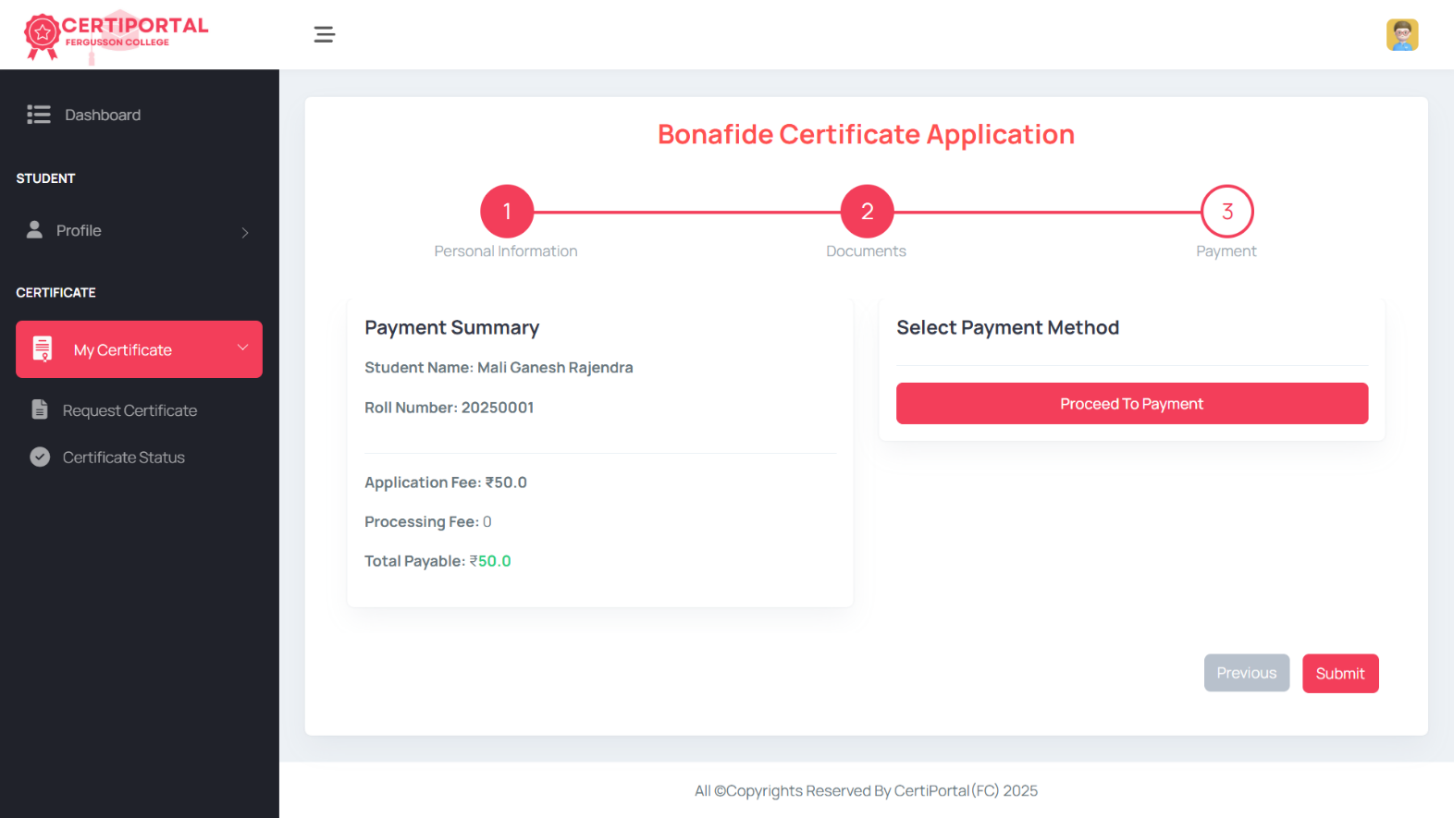

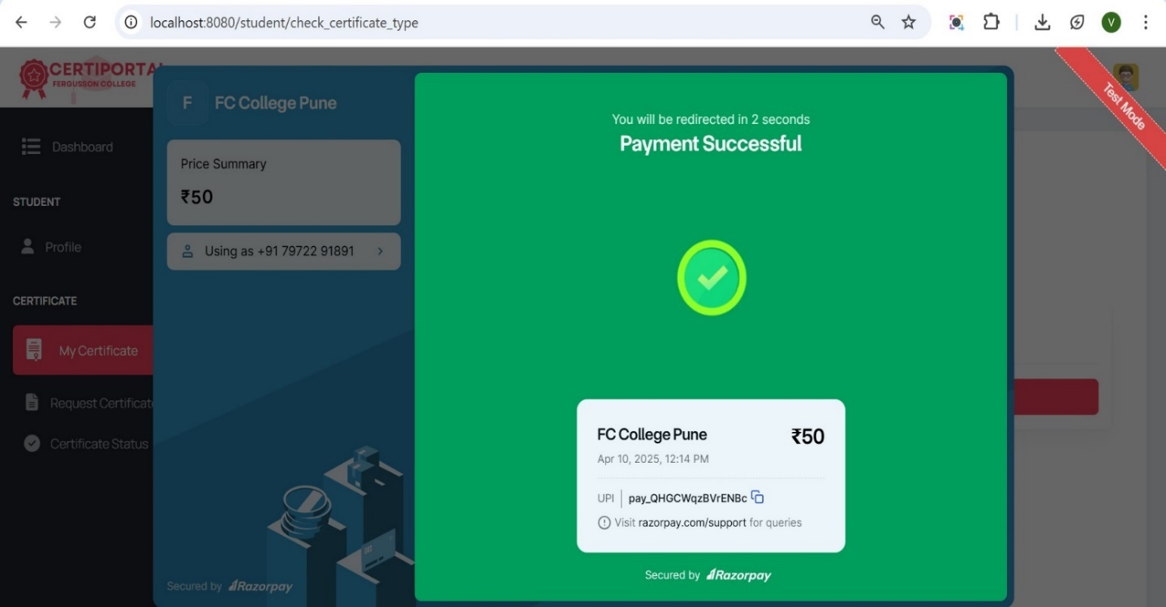

1. Admin Module Screens

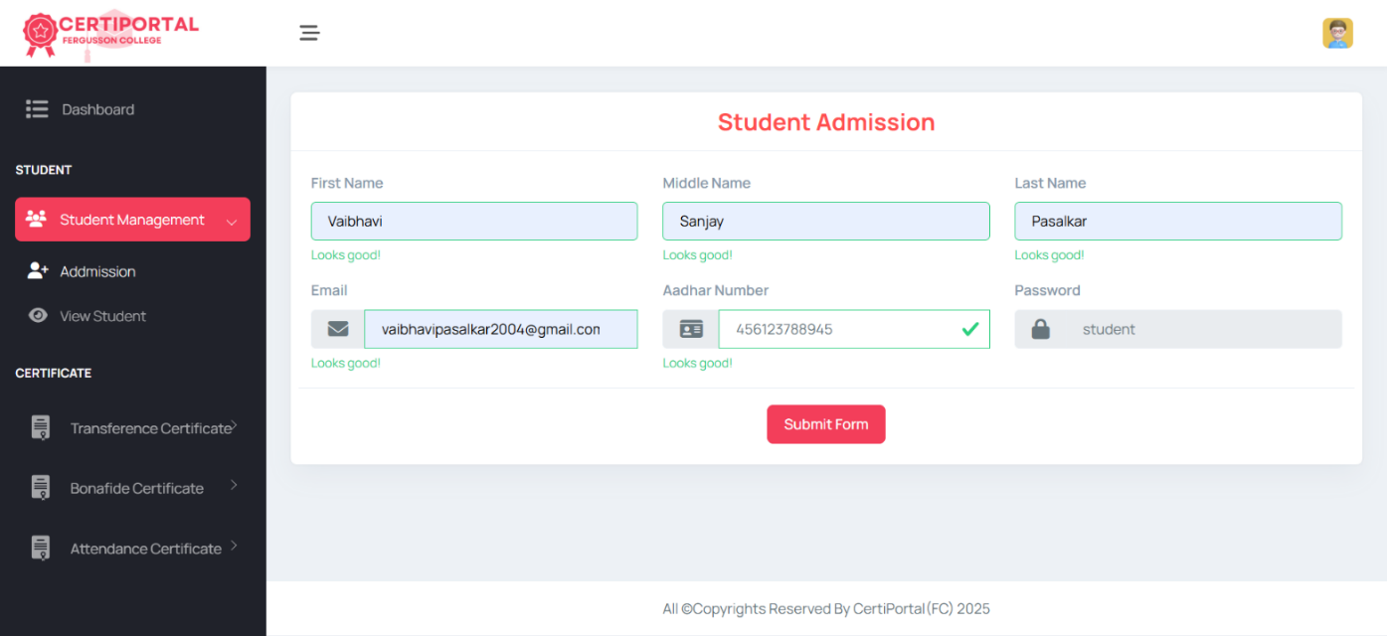

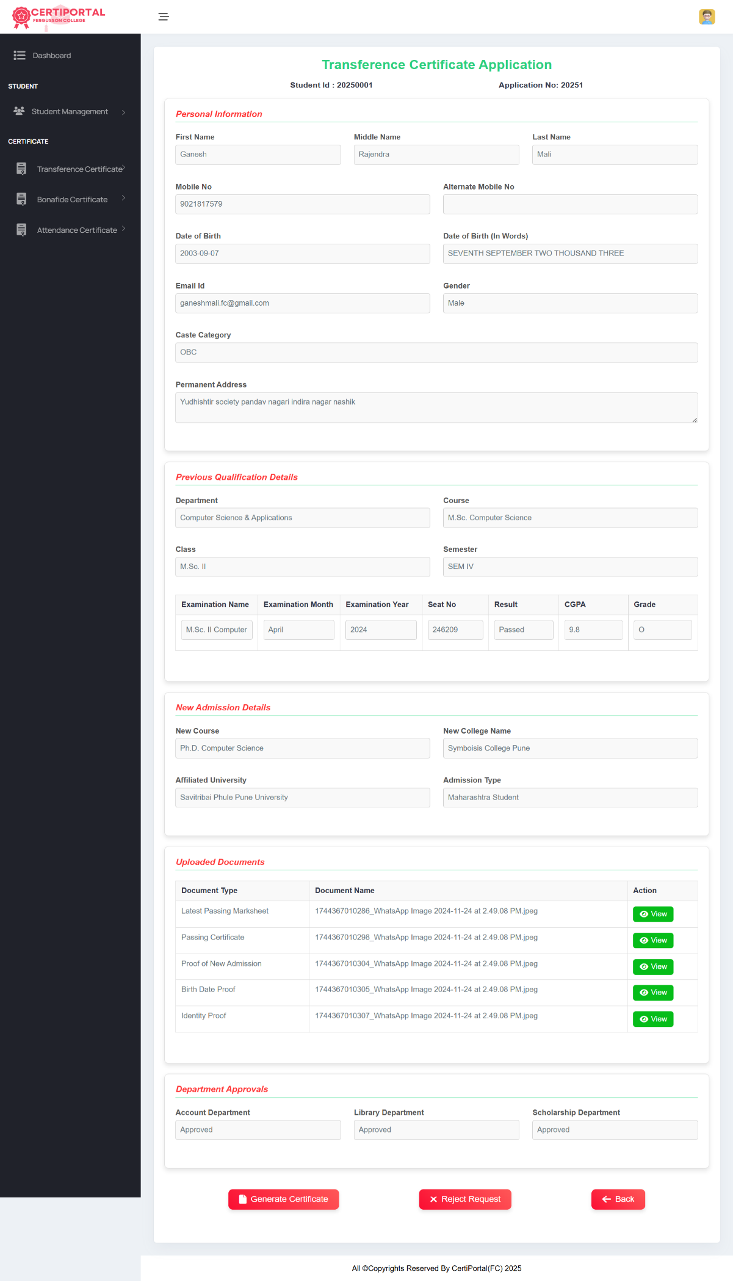

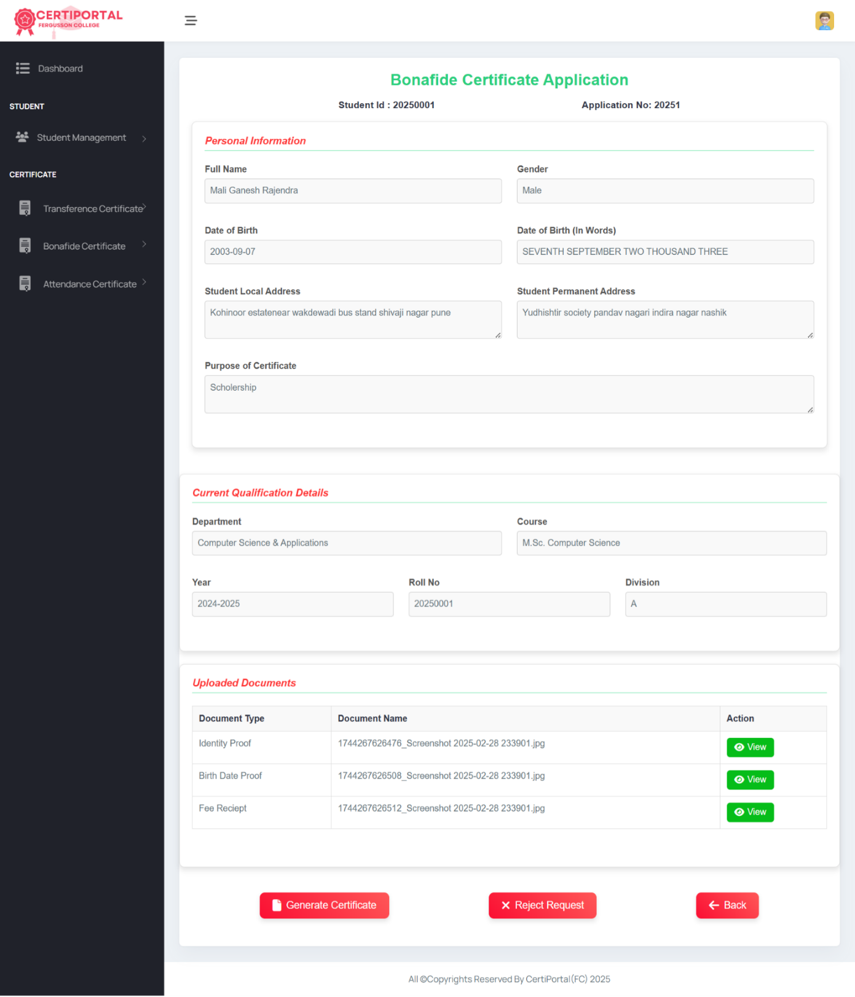

1. **Testing**
   1. **Importance of Testing**

Testing is essential for delivering high-quality software that meets user needs while minimizing risks. It acts as a quality gatekeeper throughout the development lifecycle, ensuring that every feature works as intended before reaching end-users. By systematically validating functionality, performance, and security, testing bridges the gap between developer expectations and real-world usage.

* **Early Bug Detection**
  + Catches problems when they're easiest to fix.
  + Prevents small issues from becoming big failures.
* **Improved Reliability**
* Works smoothly across different platforms.
* Minimizes crashes and unexpected behaviour.
* **Stronger Security**
  + Finds vulnerabilities before they can be exploited.
  + Protects sensitive user information.
* **Better Performance**
  + Handles heavy usage without problems.
  + Runs efficiently with quick response times.
* **Enhanced User Experience**
  + Provides smooth, error-free operation.
  + Keeps users satisfied and engaged.
* **Cost Efficiency**
  + Reduces expensive fixes later in development.
  + Saves money by preventing major issues.
* **Improved Documentation**  
  • Clearer code leads to better understanding.  
  • Helps new developers onboard faster.
* **Increases Code Reusability**  
  • Well-tested components can be reused across projects.  
  • Saves time in future development efforts.
  1. **Types of Testing**

**1. Functional Testing:** Ensures the system meets all functional requirements.

* **Unit Testing:** Tests individual modules (e.g., login, certificate request).
* **Integration Testing:** Checks interactions between different modules (e.g., student request & admin approval).
* **System Testing:** Ensures the complete system works as expected.
* **User Acceptance Testing (UAT):** Confirms the system meets user expectations before final deployment.

**2. Non-Functional Testing:** Evaluates system performance, usability, and reliability.

* **Performance Testing:** Tests system speed and efficiency.
* **Load Testing:** Checks system behaviour under multiple user requests.
* **Stress Testing:** Simulates high traffic to ensure stability.
* **Usability Testing:** Ensures a user-friendly experience for students and administrators.
* **Accessibility Testing:** Verifies the system is usable by individuals with disabilities.

**3. Security Testing:** Ensures data privacy and protection against cyber threats.

* **Authentication Testing:** Ensures only authorized users can log in.
* **Authorization Testing:** Confirms role-based access (Student, Admin, Department).
* **Data Encryption Testing:** Protects sensitive certificate data.
* **Penetration Testing:** Simulates cyberattacks to identify vulnerabilities.

**4. Database Testing:** Ensures accurate and efficient data storage.

* **Data Integrity Testing:** Verifies data consistency in the database.
* **CRUD Testing:** Tests Create, Read, Update, and Delete operations.
* **Indexing & Query Performance Testing:** Ensures faster database responses.

**5. Compatibility Testing:** Ensures the system works across different platforms.

* **Cross-Browser Testing:** Verifies functionality on Chrome, Firefox, Edge, etc.
* **Cross-Platform Testing:** Ensures the system runs on Windows, macOS, and mobile devices.
  1. **Test Cases**
* **Student Module**
* **Student Login with Valid Credentials**
* Steps: Enter correct User ID & Password, Click "Login"
* Expected Result: Student successfully logs in and is redirected to the dashboard
* Status: Pass
* **Student Login with Invalid Credentials**
* Steps: Enter incorrect User ID or Password, Click "Login"
* Expected Result: Error message is displayed
* Status: Pass
* **Logout Functionality**
* Steps: Click "Logout"
* Expected Result: Student is logged out and redirected to the login page
* Status: Pass
* **Forgot Password - Request OTP for Password Reset**
* Steps: Click "Forgot Password", Enter registered email, Click "Send OTP"
* Expected Result: OTP is sent to the registered email
* Status: Pass
* **Forgot Password - Verify OTP and Reset Password**
* Steps: Enter received OTP, Enter new password, Confirm new password, Click "Submit"
* Expected Result: Password is successfully updated
* Status: Pass
* **Mandatory Profile Completion**
* Steps: Login with default credentials, System redirects to profile page, Fill required details, Click "Save”
* Expected Result: Profile updated; student dashboard accessible
* Status: Pass
* **Profile Update**
* Login as student, Navigate to "Profile", Edit information, Click "Save"
* Expected Result: Profile updated successfully
* Status: Pass
* **Submit Certificate Request**
* Steps: Login as student, Click "Request Certificate", Select certificate type, Upload required documents, Click "Submit"
* Expected Result: Request submitted successfully and visible in student dashboard
* Status: Pass
* **Attempt Request Without Completing Profile**
* Steps: Login as student, Click "Request Certificate" without updating profile
* Expected Result: System prevents request submission and prompts to complete the profile first
* Status: Pass
* **View Request Status**
* Steps: Login as student, Navigate to "My Requests", Check status of submitted requests
* Expected Result: Status updates are visible (Pending, Approved, Disapproved)
* Status: Pass
* **Upload Supporting Documents**
* Steps: Login as student, Navigate to "Upload Documents", Select a valid file ( JPG, PNG), Click "Submit"
* Expected Result: Document uploaded successfully
* Status: Pass
* **Upload Invalid File Format**
* Steps: Login as student, Upload a file with an unsupported format, Click "Submit"
* Expected Result: System shows error message
* Status: Pass
* **Receive Notification for Certificate Approval**
* Steps: Admin approves request, Student logs in and checks status and received confirmation email.
* Expected Result: Notification for approval is displayed
* Status: Pass
* **Failed Payment Handling**
* Steps: Simulate a failed payment attempt, Check if the system handles it correctly
* Expected Result: User is notified of failed payment, and retry option is available
* Status: Pass
* **Admin Module**
* **Admin Login with Valid Credentials**
* Steps: Enter correct User ID & Password, Click "Login"
* Expected Result: Admin successfully logs in and is redirected to the dashboard
* Status: Pass
* **Admin Login with Invalid Credentials**
* Steps: Enter incorrect User ID or Password, Click "Login"
* Expected Result: Error message is displayed.
* Status: Pass
* **Logout Functionality**
* Steps: Click "Logout"
* Expected Result: Admin is logged out and redirected to the login page
* Status: Pass
* **Dashboard Displays Real-Time Statistics with Pie Chart**
* Steps:Login as admin. Navigate to the admin dashboard. Check if the dashboard displays real-time counts of total students, pending requests, approved certificates, and rejected requests. Verify if the pie chart updates dynamically based on new requests and approvals.
* Expected Result:Dashboard accurately displays total counts of students, pending requests, approved certificates, and rejected requests. The pie chart updates in real time when new requests are submitted, approved, or rejected.
* Status**:** Pass
* **View Pending Certificate Requests**
* Steps: Login as admin, Navigate to "Pending Requests"
* Expected Result: List of pending certificate requests is displayed
* Status: Pass
* **Verify Certificate Request**
* Steps: Login as admin, open a pending request, Cross-check details with records, Verify supporting documents
* Expected Result: Admin successfully verifies the request
* Status: Pass
* **Approve Certificate Request**
* Steps: Login as admin, navigate to "Pending Requests", Click "Approve" for a verified request
* Expected Result: Request status changes to "Approved", student is notified
* Status: Pass
* **Reject Certificate Request**
* Steps: Login as admin, navigate to "Pending Requests", Click "Reject", Provide reason for rejection
* Expected Result: Request status changes to "Disapproved", student receives a rejection notification via email.
* Status: Pass
* **Certificate Generation After Approval**
* Steps: Login as admin, open an approved request, click "Generate Certificate"
* Expected Result: System generates the certificate, making it available for student download
* Status: Pass
* **View Approved Certificates**
  + Steps: Login as admin, Navigate to "Approved Requests"
  + Expected Result: List of approved certificate requests is displayed
  + Status: Pass
* **View Rejected Certificates**
* Steps: Login as admin, Navigate to "Disapproved Requests"
* Expected Result: List of rejected requests with sends notification to student via email.
* Status: Pass
* **Notification to Students on Request Approval**
* Steps: Approve a certificate request, check if a notification is sent to the student via email.
* Expected Result: Student receives a notification about approval via email.
* Status: Pass
* **Access to Admin Panel**
* Steps: Try accessing admin panel without admin credentials
* Expected Result: Access is denied with an error message
* Status: Pass
* **Search and Filter Certificate Requests**
* Steps: Allow search/filter options to find specific certificate requests or any particular record.
* Expected Result: Requests are filtered correctly as per the given criteria
* Status: Pass
* **Generate Reports on Certificate Requests**
* Steps: Login as admin,", Select time range and filters, click "Generate Report"
* Expected Result: Detailed report on certificate requests is generated and downloadable.
* Status: Pass

1. **Reports**

**1. Student Module**

Dashboard:

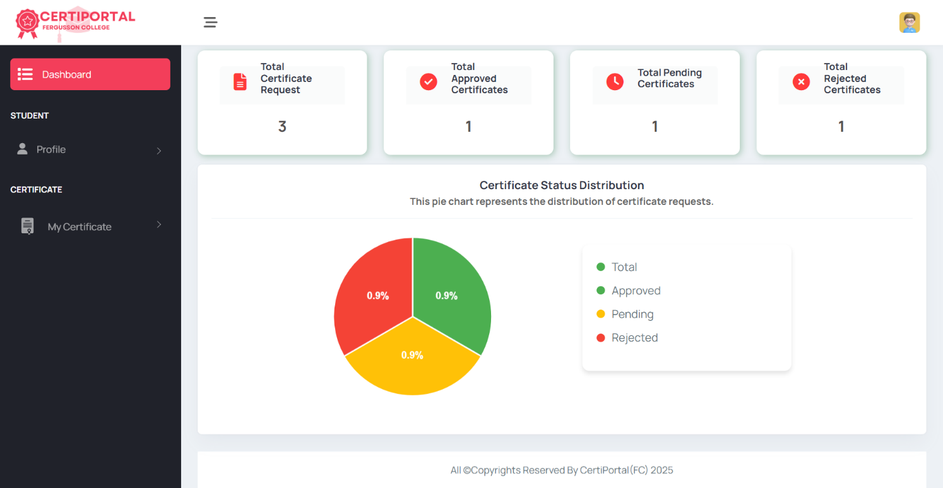

Student Certificate Status:

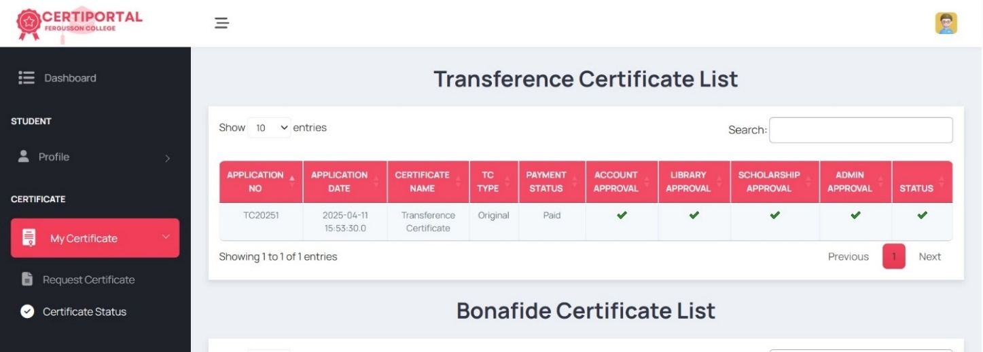

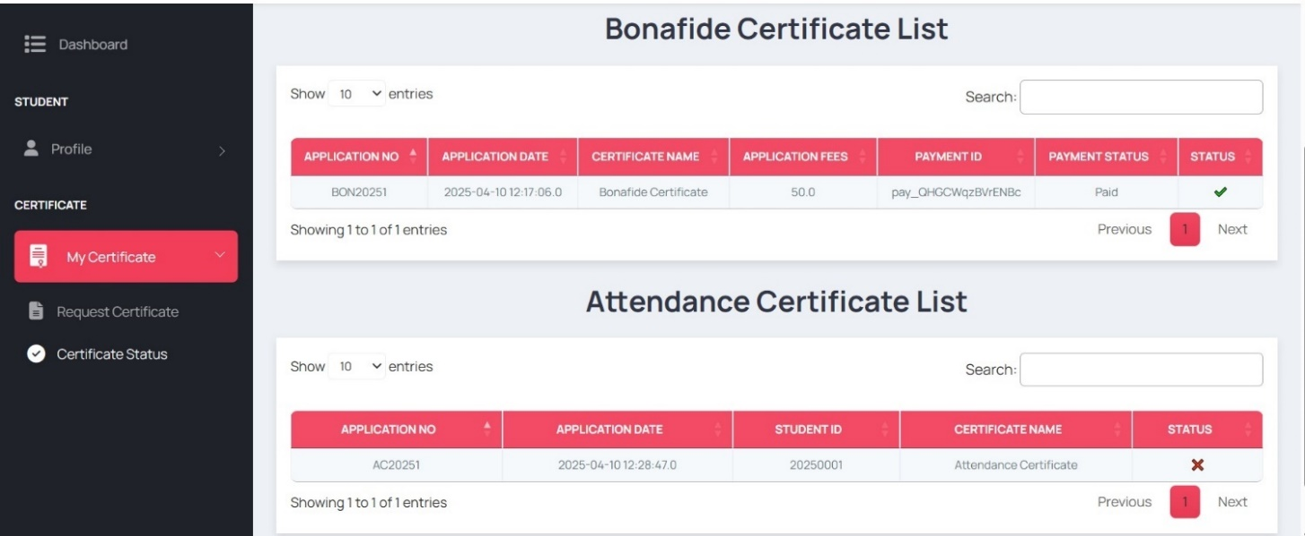

**2. Admin Module**

Dashboard:

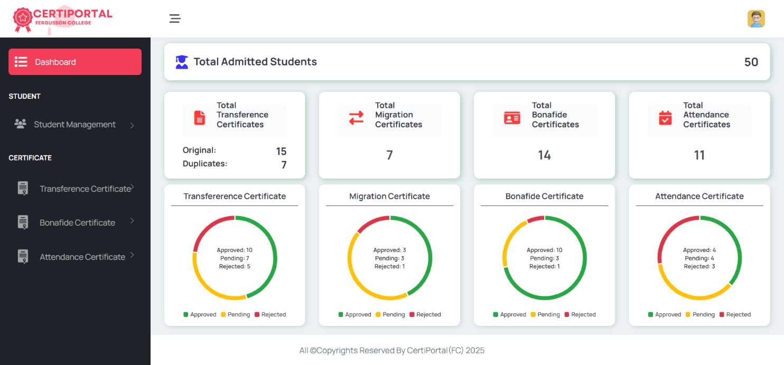

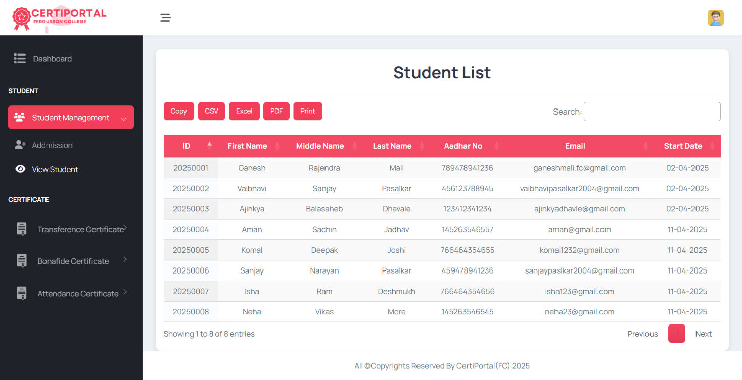

Certificate Status Report

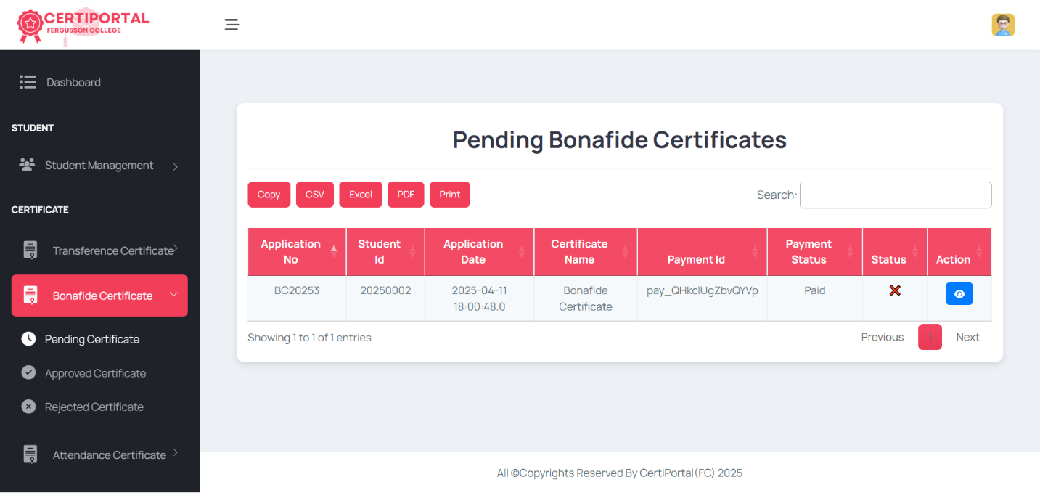

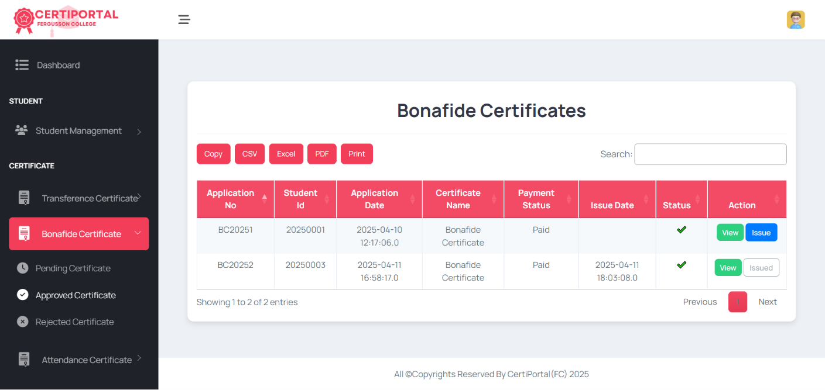

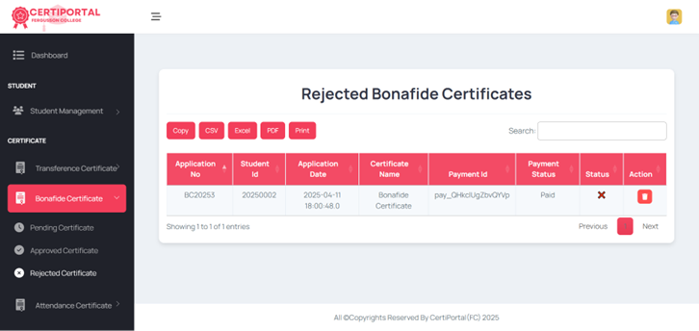

Generated Certificates

1) Transference Certificate

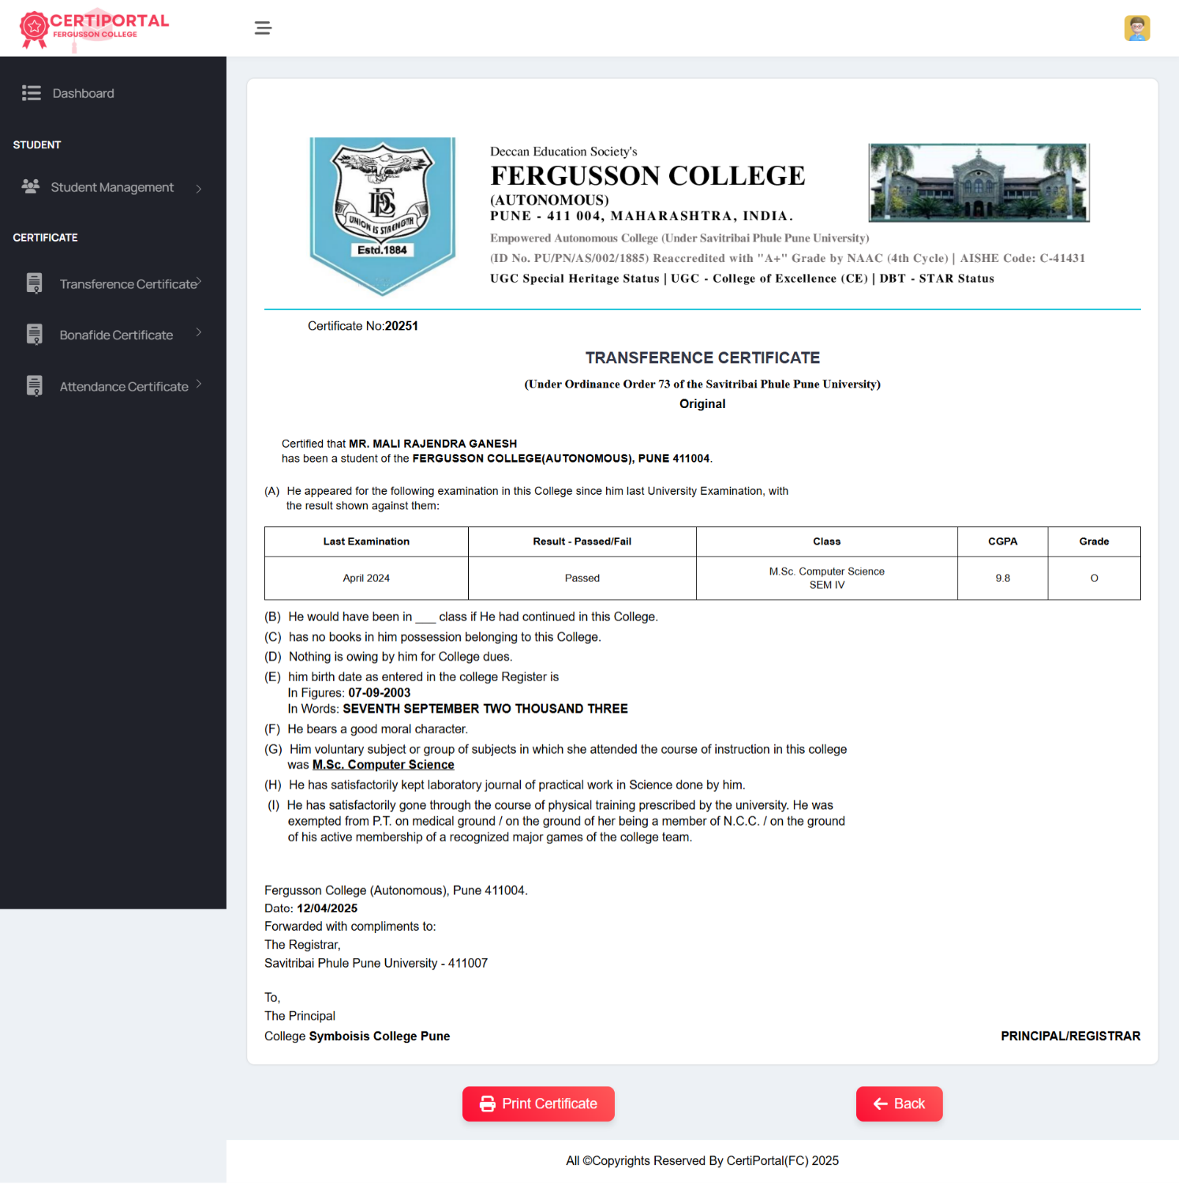

2) Bonafide Certificate

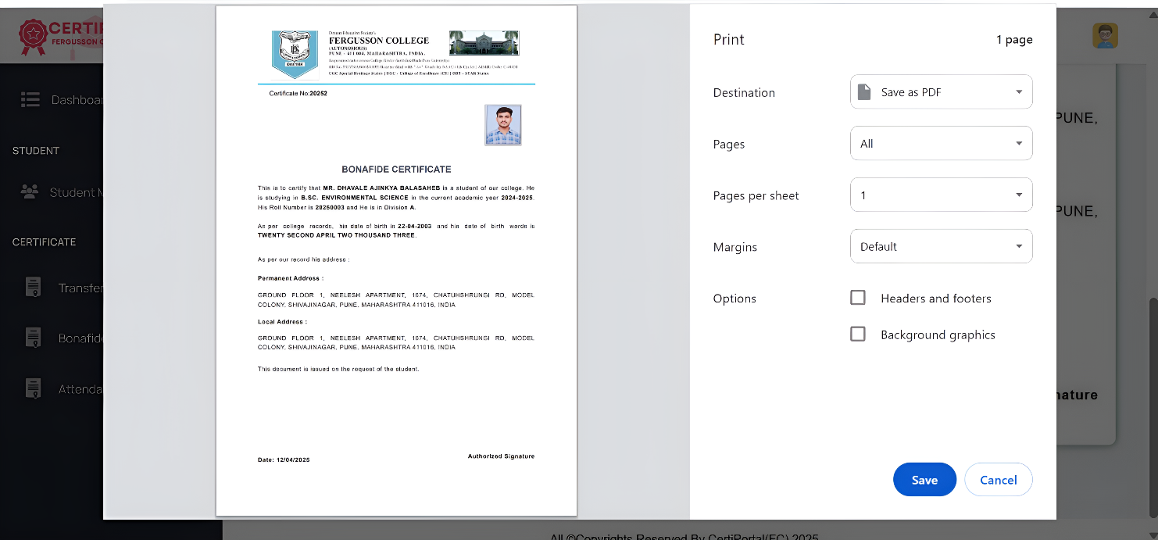

**3. Sub Module**

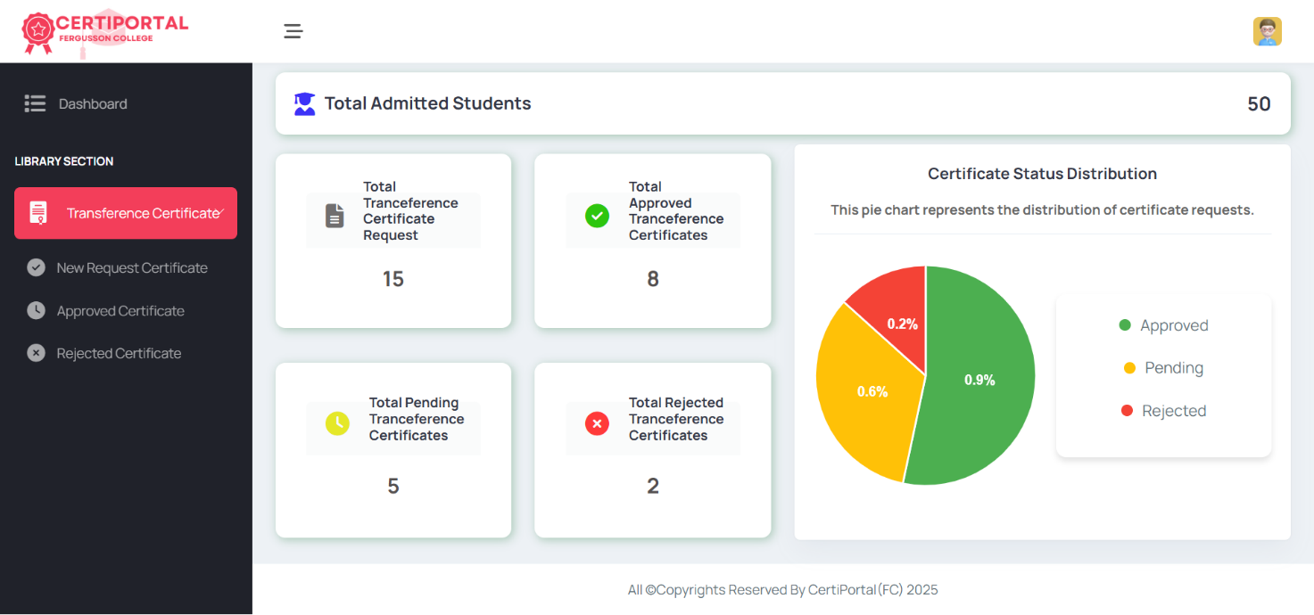

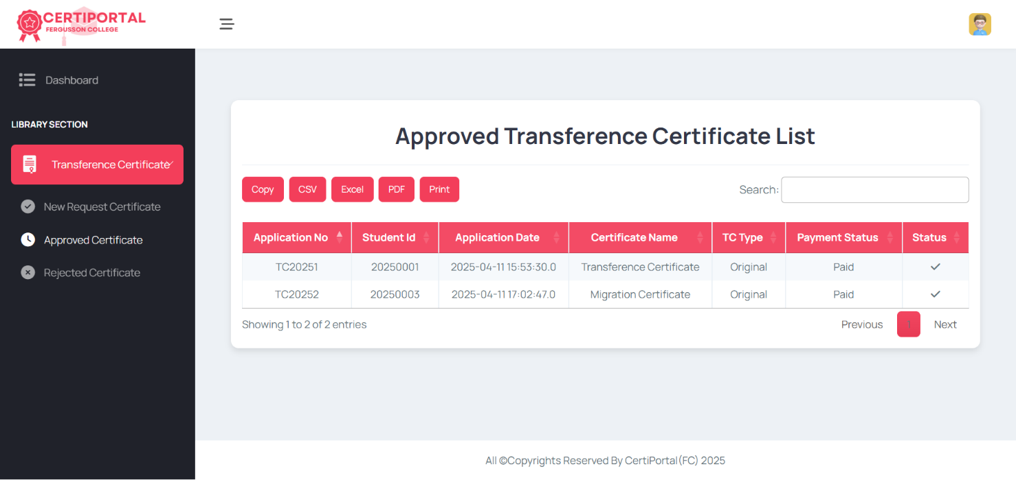

1. **Drawbacks and Limitations** 
   1. **Drawbacks**

* **Internet Dependency**: The system requires a stable internet connection; any network failure can hinder accessibility.
* **Potential System Downtime:** Maintenance or technical issues may temporarily disrupt access to the platform.
* **Limited Offline Functionality:** The system does not support offline access for certificate requests and approvals.
* **Data Entry Errors:** Incorrect student details entered into the system can lead to certificate generation errors.
* **Maintenance Required:** Regular updates and security checks are needed to keep the system running smoothly.
* **Single Point of Failure:** If the central database crashes, the entire system may stop working until it is fixed.
* **Dependence on Admins:** If the admin does not verify requests on time, certificate processing may get delayed.
  1. **Limitations**
* **Fixed Certificate Formats:** Certificate designs have fixed formats that might not suit all institutions.
* **Storage Limitations:** Large volumes of certificates and documents may require additional server resources over time.
* **Security Risks:** If not properly maintained, there is a chance of cyberattacks or data leaks.
* **May Slow Down with More Users:** If too many people use the system at the same time, it may become slow.
* **No Multi-Language Support:** The system may not support different languages, limiting accessibility for some users.

1. **Future Enhancement and Conclusion**
   1. **Future Enhancement**

* **Digital Signature and Blockchain Verification**

Implement digital signature technology and blockchain for tamper-proof certificate verification and enhanced security.

* **Multi-Language and Accessibility Support**

Offer support for multiple languages and accessibility features to cater to a diverse user base, including those with disabilities.

* **Advanced Analytics and Reporting**

Introduce robust analytics dashboards that provide insights into trends, request processing times, and system performance for continuous improvement.

* **Mobile Application Integration**

Develop native mobile apps for students and administrators to enable certificate management on-the-go.

* **Enhanced Notification System**

Integrate SMS alerts to provide instant updates on request statuses, approvals, or required actions.

* **Integration with University Management Systems**

Seamlessly connect with ERP, LMS, or other institutional systems to automatically update student records and synchronize data.

* **Enhanced Security Measures**

Introduce multi-factor authentication, biometric verification, and end-to-end encryption to safeguard sensitive data.

* **Customizable Certificate Templates**

Allow administrators to design and customize certificate templates to meet changing institutional branding and regulatory requirements.

* **Automated Document Verification**

Incorporate OCR (Optical Character Recognition) and AI-based verification to automatically validate uploaded documents and reduce manual review time.

* **Chatbot and Virtual Assistant Integration**

Add a chatbot or virtual assistant for real-time support, guiding students through the certificate request process and answering FAQs.

* 1. **Conclusion**

The **CertiPortal** - **Academic Certificate Generator** effectively replaces the traditional, manual certificate issuance process with an automated and efficient system. By enabling students to request certificates online, track their status in real-time, the platform enhances accessibility and convenience.

For administrators, the system simplifies request verification, approval workflows, and certificate generation, reducing paperwork and processing delays. With role-based access control, seamless departmental collaboration, and a centralized database, it ensures accuracy, security, and transparency.

This project not only improves administrative efficiency but also enhances the overall student experience by minimizing delays and reducing the need for physical visits. Future enhancements like digital signatures, mobile integration, and advanced reporting can further expand its functionality, making it a scalable solution for educational institutions.

1. **Bibliography**

* College References:
* Academic documents and guidelines for certificate issuance.
* Existing manual procedures such as certificate request forms and documentation followed by the institution for certificate management.
* Websites
* <http://www.w3schools.com>
* <https://stackoverflow.com>
* <https://fontawesome.com/>
* <https://getbootstrap.com/>
* [**https://spring.io/projects/spring-boot**](https://spring.io/projects/spring-boot)